**Amherst Youth Lacrosse, Inc.**

Board or Directors Meeting

Newman Center, UMass

Date: February 16, 2017 Time: 7pm

1. Welcome and President update - Andrew

* Coaches meeting update

1. Approval of 12/3/16 Minutes (Page 2) - Andrew
2. Team coach status - Andrew

* Boys Bantams – Sam Hazen (AC), Rob McAllister (AC), Rich Ferro (AC)
* Boys Juniors – Henry Wilson (HC), Rich Ferro (AC)
* Girls Bantams – Jim Chambers (HC), Cara Foster (AC)
* Girls Juniors – Pat Schilling (HC), Sandi Burkett (AC)

1. Current registration status (Page 3) - Andrew
2. Practice Schedule (Page 4) – Andrew, et al
   * Field options
   * WHIP program
   * Amherst College
3. Uniform and Equipment update – Andrew & Pat
4. 2017 Draft Budget – Andrew, Alvie & Cara
5. Fundraising options – Pat
   * Car wash
   * Golf tournament
   * Cookie decorating party
   * UMass Men’s gamewatch
   * NCAA Championship
   * Apparel and brand building (Squad Locker, etc.)
6. Other Business
   * Future BOD topics:
     1. Town league best practices
     2. Website improvements and alternate communication options (TeamSNAP app)
   * Next coaches meeting will be in early March
   * Next full BOD meeting TBD
7. Adjournment

**Amherst Youth Lacrosse, Inc.**

Board or Directors Meeting

Newman Center, UMass

**December 13, 2016 Minutes**

Present -Andrew MacDougall, Alvie Borell, Sandi Burkett, Cara Foster, Frank Hein, Patrick Schilling

7:05 start - Minutes from last meeting approved

Team coach status discussed

Sr. Boys & Sr. Girls will be Middle School Teams organized by the Athletic Director

Patrick volunteers to run Mini-Mite program

Age designation USL changes impacts need to be understood - Boys plan to adopt

4v4, 7v7, 10v10 -?

Status of East St. School field? Will require a spring cleanup of brush around the perimeter

Enrollment due end of January for out of town waivers. Enrollment period 2-3 weeks?

Marketing ideas: LSSE, sell swag, Learn-to-play @ UMass, PGO Newsletter, Flyers @ schools, Scouts.

Choose date and kids for in school promotion.

Early practice opportunities? Amherst College contact? UMass- Angela McMahon

What are college spring break dates?

Fund raising- Car wash, Jamie Mullins golf raised $800 dollars last year with no AYL involvement. Next date for golf? How can AYL help?

Patrick- NCAA finals end of May @ Foxboro. Coach bus $3000. Maybe a Potter van. Play a 10 minute halftime game? Youth game before a UMass game? Call Dan. More ideas needed: Triton swim-a-thon, wall ball challenge, calendar raffle. Coupon books

Other business: Pippa could look into best practices

Ensure use of Middle School field with AD Ferro. What about Crocker / Fort River fields?

Next BoD meeting in January, coaches meeting in February?

Put clinics on web-site

Girls schedule is set in March

Meeting adjourned 8:00 pm

**Tentative Practice Schedule**

If all activities at the Middle School and Wildwood, then Boys 10U could have full access to Wildwood while Boys 12U, Girls 10U and Girls 12U would need to share the MS.

Recommend Girls 10U stay on two fields at MS while Girls 12U take 1 or 2 fields at the HS.

|  |  |  |  |  |  |  |  |
| --- | --- | --- | --- | --- | --- | --- | --- |
|  | **Sunday** | **Monday** | **Tuesday** | **Wed** | **Thursday** | **Friday** | **Saturday** |
| **10U Boys** | WW | WW | WW | WW | WW | WW | WW |
| **12U Boys** | MS > 2pm | X | MS | X | MS | By Agreement | MS > 12pm |
| **10U Girls** | MS < 2pm | MS | X | MS | X | By Agreement | MS < 12pm |
| **12U Girls** | HS | HS | HS | HS | HS | HS | HS |

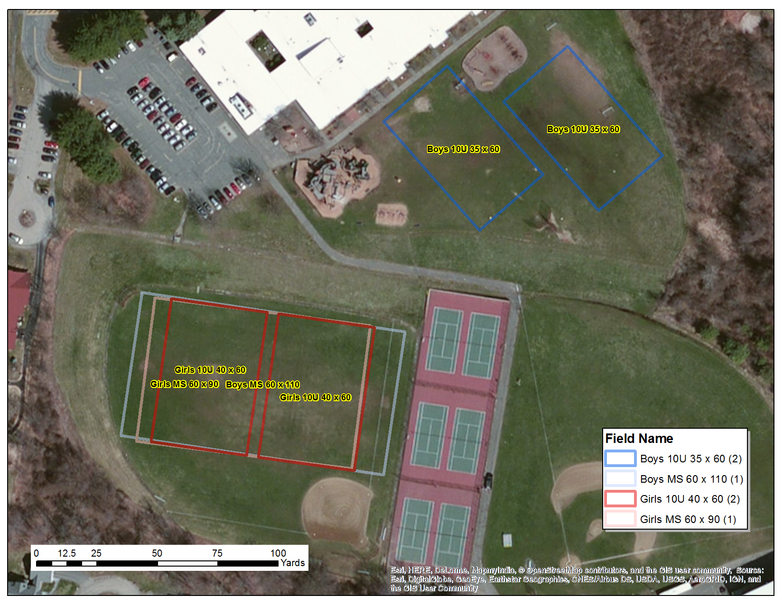



**-DRAFT-**