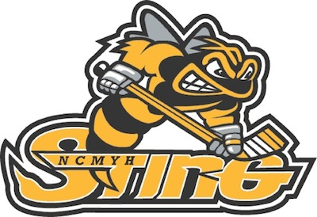
NORTH CENTRAL MASS YOUTH HOCKEY
2015/2016

Dear Community Partner:

North Central Mass Youth Hockey “Sting” is a nonprofit organization that supports an amazing group of enthusiastic children from the Ash-West, Gardner and Winchendon towns along with surrounding areas. Our program encompasses Travel Ice Hockey Teams, Learn to Skate, Learn to Hockey and our new local House Hockey Program for those unable to play on a travel team. Our players consist of children ages 4 through 18 and this season we are estimating over 120 players on our travel teams alone.

Last season, our Sting teams succeeded in winning multiple regional tournaments and a championship title while climbing high in the ranks of our respective divisions. This year, we are determined to continue our growing success! Money received from Community Partners, such as yourself, is absolutely critical in our ongoing development and goal of keeping our tuition costs the lowest in the area. Your donation will help us offset expenses such as:

- Hockey nets, pucks and other equipment
- Goalie and Skating clinics
- Team uniforms and practice jerseys
- Local exhibition games and referees

We are asking for your support and a donation of any amount would be utilized but with a minimum contribution of $100.00 we will feature your company’s logo and website link on the NCMYH website. For contributions of $250.00 or more we will also feature your company’s name and logo on our “Sponsor’s Banner” hanging in Cushing Academy’s snack bar during all hockey events as well as at all local NCMYH Exhibition Games, Fundraisers and Promotional Events.

Thank you in advance for your time and anticipated support. If you have any questions, please feel free to contact me at 978-502-8013 or email at brogie27@gmail.com. Please use the use the bottom portion to submit your donation payable to NCMYH.

Yours truly,

Shane Brogan
North Central Mass Youth Hockey / Sponsor Coordinator

Please return the bottom portion with your donation _____________________________________________________________________________________________
Business Name: ____________________________________ Contact Person: ___________________________
Address: __________________________________________ Phone Number: ___________________________
___________________________________________ Website: ________________________________

Donation Amount: $50 $100 $250 $500 other ________
NCMYH - PO Box 212, Gardner, MA 01440

