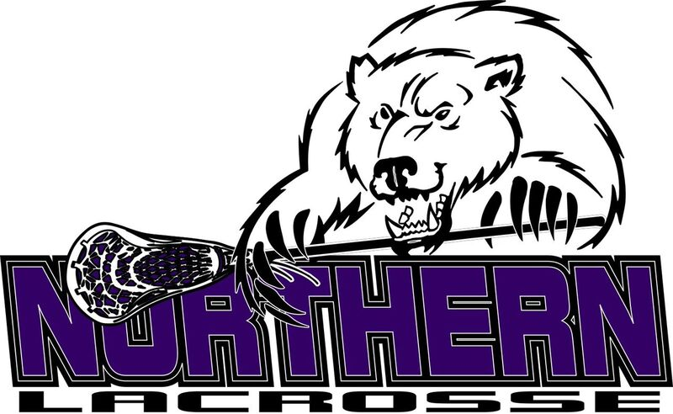
Polar Vortex Application
When: May 6, 2017
Where: 589 Chestnut grove rd. Dillsburg, PA 17019 (Northern home field)
Cost: $250.00 for each grade registered.
Please complete the following:
Team: ______________________________________________________________
3rd and 4th grade____ Number of players______
Coaches__________________________________ _
5th and 6th grade_____ Number of players______
Coaches
7th and 8th grade_____ Number of players______
Coaches

Shirts are available for an extra $50.00 per team.
**Please remember all roasters and proof of grade level (report card) will now be required to be brought to the tournament in the event a player’s age is questioned during a game.

If you have any questions please feel free to contact Adam Baker at 717-448-2842 or email Jessbaker03@yahoo.com . Please mail this form and check to Adam Baker, 315 E Portland Street Mechanicsburg PA 17055.

