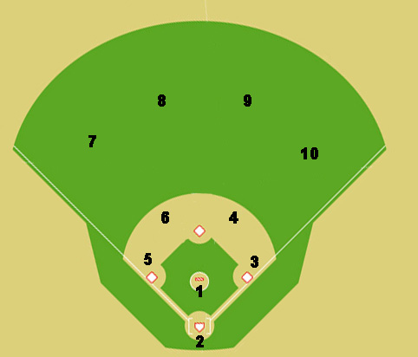
x

.
x

x

Situation #3: No outs, runners on first base and third base. The ball is hit to second (red dot is ball). Where does everyone go and where do you throw the ball?

