Breaking Down Hitting

Hitting a softball is not easy if you don't have the right fundamentals nailed down. I have researched this in depth and put together a variety of sources to provide you with a thorough tutorial. There are many different schools of thought on how to teach kids to hit the ball. I have watched and read about them all, looked at the science and the rotational swing looks to be the one most used by successful softball and baseball players. Please recognize that this is not the easiest method, they are not just swinging their arms. But if done correctly, will enable the girls to engage their entire body in hitting (you will see that swing is not really mentioned, this is all about putting your body into hitting the ball).

The Right Grip
When gripping the bat, the hitter needs to apply pressure with the fingers, not the palms. She grips the bat where the calluses are. The bottom hand which would be the left hand for a right-handed batter controls the bat, and the top hand supports the bat loosely. The bottom hand grips the bat just like a person would grip a hammer or a golf club.
The top hand is placed against the bottom hand with the door-knocking knuckles (middle knuckles) of both hands in a straight line. The arms are not crossed. The bat is gripped loosely and the wrists have some flexibility.

Some hitters curl the index finger of the top hand so that it only lightly touches the bat. For better bat control the player may choke up on the bat by moving both hands several inches up from the knob. A choke grip means a shorter bat and less power.

Hand Position
The hands start close to the body about three to four inches in front of the chest and between the shoulders. Both elbows are down, and the shoulders are tension free. Some players prefer a little movement back and forth with the hands and shoulders to keep them loose. This position is known as the power position, or power alley.

Stance
The stance – player’s use the open stance, the closed stance or square stance. For our beginners let’s start with the square stance. The girl’s body should be square to the plate. Both eyes straight at the pitcher and level. We don’t walk around with our head tilted, we walk with our eyes level – that is how the batter’s head should be. She then takes her hands and brings them back behind her ear (as her head is turned looking at the pitcher) with the bat at a 45 degree angle. Elbows are relaxed, downward but not close to the body. Not up. Girls should be moving and relaxed. Not ridged.

Weight transfer is NOT a hitting technique, but rather an element of hitting, and a major one at that. There has to be back to front movement in a players swing in order to hit with any kind of consistency and power. Sitting, squishing the bug is simply poor mechanics. Great swing mechanics are initiated with a forward movement and a subtle shift from the back to the front.
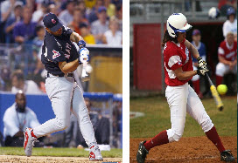
Watch the back foot – players are either on the tip of their back foot, or the foot is completely off the ground at contact. This is what good weight transfer looks like and there has to be back to front motion in the swing. There is no sitting, there is no squishing.

Hips & Core
Turning to the ball with the hips leading the way is such a huge part of hitting and is an area that a majority of young players never fully develop. The power that is generated by the hips in a baseball swing is based on the principle of torque. The same way a golfer, boxer, tennis player and pitcher use their core muscles to turn, so do the best hitters in the game. Players need to “learn to turn” to the ball.

Leveling
Leveling is the technique that allows the bat to drop down into the path of the ball, and is irrefutable as to whether it is really happening, because it is. Dipping the back shoulder, dropping the barrel of the bat level to the ball and swinging up through the oncoming pitch. Note: In order to level the bat has to drop down. Do not confuse this with swinging down, because it is not.
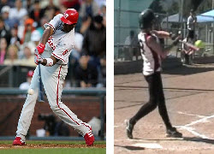
The process of the elbow working up and around the body is an essential part of leveling and the only way a player can ever get the barrel where it needs to be.

Ideal Impact
Ideal impact is hitting with your hands “inside” the ball. A couple things have to happen to make ideal impact; one, you have to let the ball travel deep enough into the hitting zone and two, your front elbow has to move up and around your body.
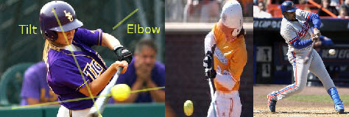
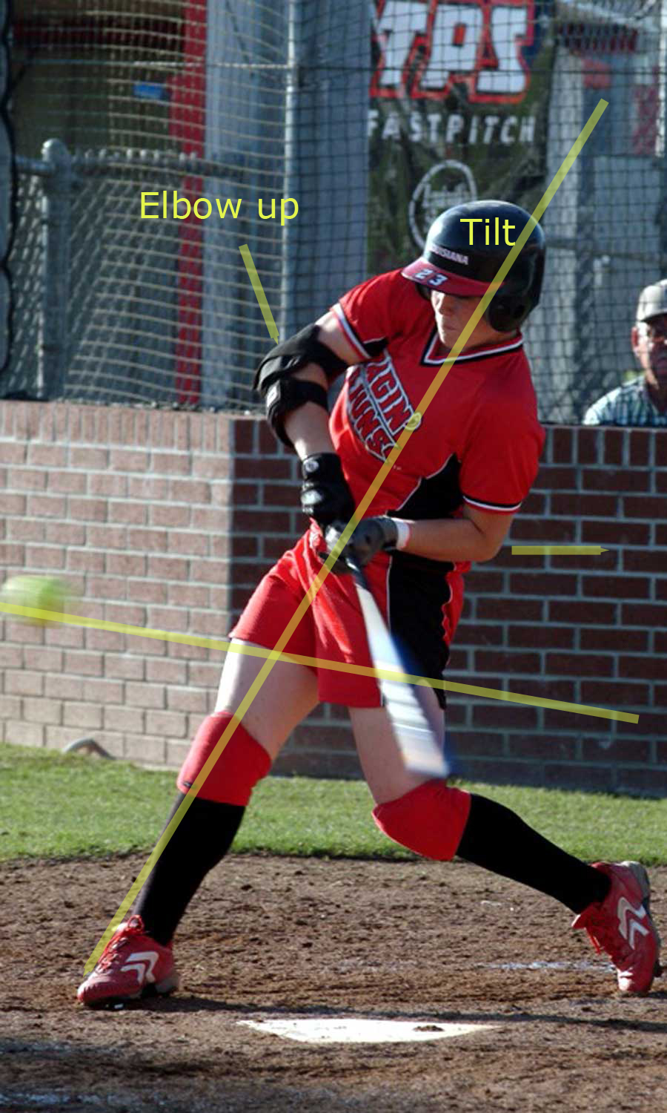

Extension & The Power “V”
Finally, we will take a look at “Extension” and the long part of the swing, also referred to the Power “V”. Great swing mechanics can be broken down into two simple elements; short and compact to the ball, long through the ball. It is this concept of “getting long” that really sets the great hitters apart. The longer a player can keep the bat in the plane of the pitch, the better chance they will hit the ball and make contact. High Level players understand the importance of keeping the wrists square at contact and push through to the “V” without rolling through the ball, but rarely is it taught. You simply cannot ignore the significance of having a long swing and keeping the bat in the plane of the ball as long as possible. It is way too important. Teach your players short to the ball, long through it!
