Spreading the Word

-Sample Letter-

Hello Family and Friends!

You’ve all heard me talk about it…and finally the time has arrived for Jimmy Fund Little League to begin! I can hardly wait for this year’s tournament and hope that my team makes it to the championships! More importantly, I — along with thousands of others — am hoping to raise more than $250,000 for the Jimmy Fund and Dana-Farber Cancer Institute. With your help, I know we can reach this goal!

The money raised goes directly to lifesaving cancer research and care at Dana-Farber. I am participating in this program on behalf of the many people this terrible disease has touched—mothers and fathers, grandparents, brothers and sisters, friends, and neighbors.

I would greatly appreciate your cheers from the bleachers and your support of my fundraising efforts. Please mail your contribution in the enclosed
self-addressed envelope or visit (include the link to your personal fundraising web page here) and help us take a swing at cancer!

Thank you.
Sincerely,

Player Name
[Town Name] Little League

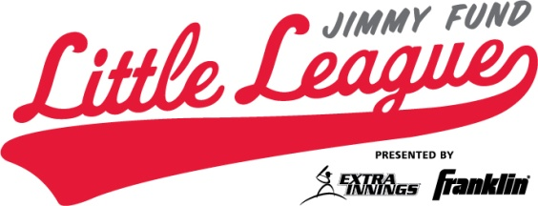
Fundraising Tip

A personal letter or e-mail sent to friends and family is a great way to reach a large audience and raise vital funds. Make sure to include the link to your online fundraising web page. You can easily
e-mail all of your contacts with a simple click at
JimmyFundLittleLeague.org

