Boys Youth Team Manager
Purpose: The role of the team manager is to be the key off field contact for the team.
General Responsibilities:
- Communicate weekly schedule and field maintenance volunteer assignments to the team via email and team webpage posting (generally on Sunday)
  - Please note: field maintenance volunteers are already assigned and scheduled. The manager includes those people in the team weekly schedule as a reminder.

- Confirm games (times & fields) with opposing teams on Monday or Tuesday for that weekend’s games.

- Reschedule games with opposing teams as needed.
  - For example – a rainout or other needed change.
  - You will work with your team’s head coach to confirm a date/time that works.
  - Once determined it will be changed on the team website.

- For Home Games (4-6 per season):
  - On Friday - Check referee website to ensure referees are scheduled, game time and location is correct.
    - Arbitersports.com
      - Login: ljanzenhome@gmail.com / Password: 572564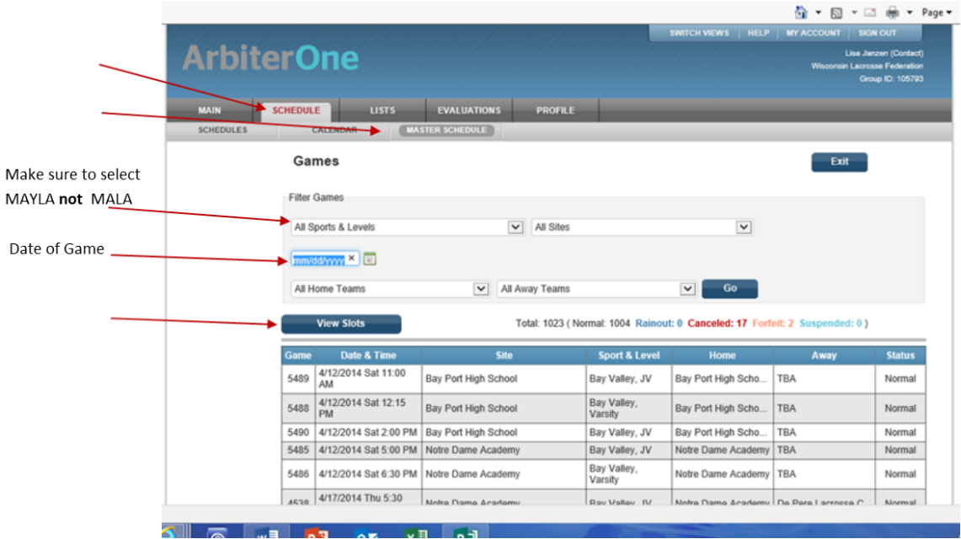
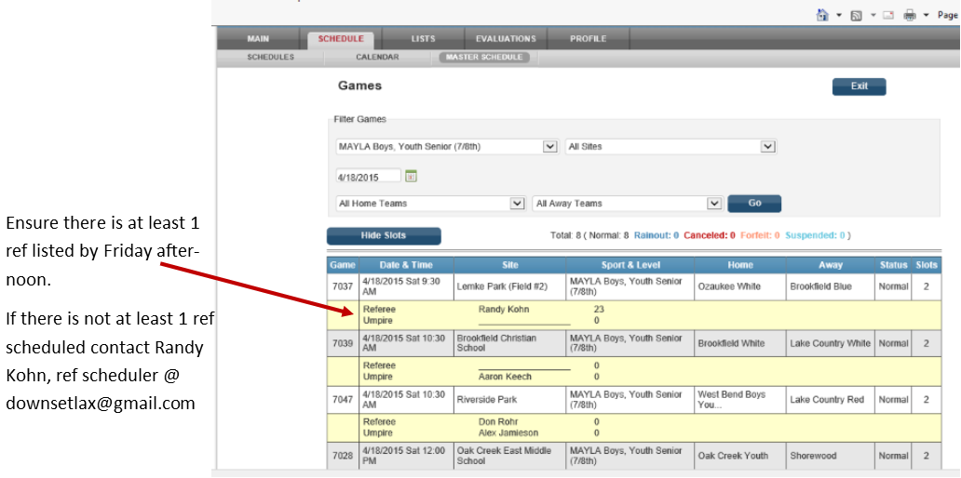

  - Pay referees (boys youth director will provide payment for all games at the start of the season)

- Distribute spirit wear and uniforms to team members when they come in.
  - You will get the items from the respective coordinators.
Other notes:
- It is not necessary to attend every practice.
- You will receive the coaches/managers email from the Boys Youth Director on Friday/Saturday that includes info for the weekly team email.

Team Website Login: your user id & password: 572564

Time Commitment: Approx 2 hours per week.

