10 yd

5 yd

LOS

L C R

SPLIT TEE QB
RUN RIGHT
FLIES H
RUN

10 yd

5 yd

LOS

L C R

RUN
QB SPLIT TEE
RUN LEFT
H FLIES

10 yd
Post
Flag

5 yd

Circle
Curl

LOS

L

C

QB

F
H

R

SPLIT TEE
CIRCLE
POST - FLAG -
Fly

10 yd

5 yd
In

Curl

Arrow

LOS

L C R

SPLIT TEE QB
ARROW F
CURL – FLY - OUT H

10 yd
SHORT YARDAGE
TWO POINT PAT

5 yd
In

Out

Curl

Slant
In

LOS

L C R

SPLIT TEE
OUT
IN - CURL - SLANT

QB
F

H

5 yd
Fade Out

Curl

LOS

L C R

SPLIT TEE
Flare
Curl - FadeOUT -

QB

F

H

Flare

5 yd Ou

Slant
In

LOS

L C R

SPLIT TEE QB
OPTION PASS
Slant IN - POST - H

OPTION PASS

10 yd

Fly

5 yd

LOS
L C R

QB
SPLIT TEE
H RIGHT REVERSE

Fade In

5 yd

Curl
Curl

LOS

L H C R

In

5 yd
In

In In

LOS

L H C R

Fade In

5 yd

Slant
In

LOS

L H C R

5 yd
Fade Out
In

Curl

LOS

L H C R

Fade In

5 yd
Out
Out

Slant
In

LOS

L

C H R

Fade Out Fade In

5 yd

Slant
In

LOS

L

C H R
Fly Fly

10 yd

5 yd
Ou

Curl

LOS

L

C H R

10 yd
SHORT YARDAGE
ONE POINT PAT

5 yd

Slant
In
Out In

Curl

LOS

L

C H R
Out

10 yd

Out

Out

5 yd
Out

LOS

L H R C

QB

Flag

5 yd
Cur l

Curl

LOS

L H R C

QB

5 yd

Slant
Out
Slant
In

Slant
In
Slant
Out

LOS

L H R C
Fly Fly

10 yd
Flag
Post

5 yd

LOS

L H R C

10 yd

Fade In
Fade In
Fade Ou

5 yd

LOS

C
QB

L H R

TRIPS RIGHT
REVERSE
Fly

10 yd
Post

5 yd In

Slant
In

LOS

C

L H R

QB TRIPS RIGHT
Left to Right
Progression

10 yd
Curl

Out

Curl

5 yd

Curl

LOS

C
QB

L H R

TRIPS RIGHT
SUPER CURLS
Fly

10 yd
Flag

5 yd
Fade In

Ou

LOS

C

L H R

QB TRIPS RIGHT
FLY – FADE IN – FLAG -

10 yd

5 yd

LOS
BACKUP and
MASTER FORMS

Fl1a0gyd
PosPt ost
Flag Post
Flag

u
Fade Out | Fade IFnFade | Out | Fade In | Fade | In | Fade O
O5utyd | InOut |  | In | In |  | Ou

Slant
Out
Curl
Slant
In

Slant
OuCitrcle
Curl
Slant
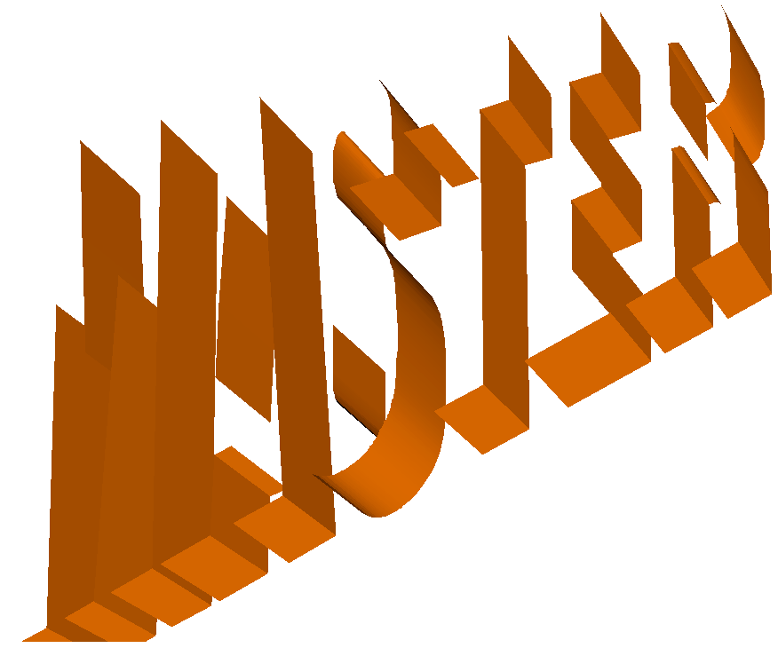In

Slant Curl
In

Slant
Out

LOS
In Out

L C

Arrow
R

SPLIT TEE QB HALFBACK ROUTE RECIEVER ROUTES H
Flare

Fl1a0gyd
Flag
PosFtlag
Post
PostPost
Flag

u
Fade Out | Fade OFOFa | udte | IFnFade OF | uatde | In | Fade | In | Fade | In | Fade O
O5utyd | Out |  | InOut |  | In |  | In | In |  | Ou
Out | Slant  Out | In | Curl  Out | In |  | In |  | Slan  In | t Curl | Slant  Out

LOS

L H C R

Fl1a0gyd
PosFtlag
Post
PostPost
Flag
Flag

u
Fade Out | Fade IFnFade | Out | Fade FIna | de In | FadFea | dIen Out Fade O
O5utyd | InOut |  | In | In | In | Out | Ou

Out

In Out

Slant
In In
Curl

In In

Out

LOS

L

C H R

1F0laygd
Flag
Post
Flag
Post
FlaPgost Po

Fade Out
FadFeadOeutIn
FadFeadOeuItn
FaFdaedeInOut
Fade I

O5 uydt

Out
Out In

Slant
OuItIn
Out In

Curl

OuItn
Out In I

InOut In

LOS

L H R C

QB

TRIPS LEFT

10 yd

5 yd

Circle

LOS In Out Arrow

Flare

H
Fly

Fly

10 yd
Flag

Post

Flag

Post

Fade Out
5 yd
Out

Slant
Out
Fade In

In

Curl
Slant
In

Fade Out

Out

Slant
Out

Fade In

In

Curl Slant
In

LOS

C R

10 yd
Flag

Fly

Post

Post
Fly

Flag

Fade Out
5
yd

Out

Slant
Out

Fade In

In

Curl
Slant
In

Fade In

In

Slant
In
Fade Out

Out

Curl
Slant
In

LOS

H L

