FYBL PRE-TRYOUT CLINICS
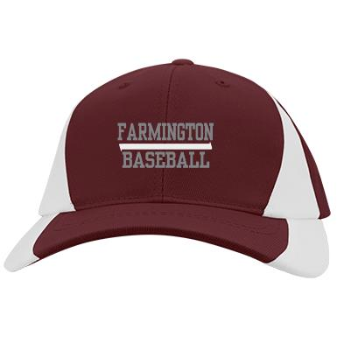

Join Farmington High School Baseball
Coach Mike McGuire & FHS Varsity Players
To Tune up for the Upcoming FYBL Tryouts

WHEN: Friday, March 3, 2017 – Session 1
Saturday, March 11, 2017 - Session 2
(Players can sign up for one or two sessions)

WHERE: Around the Horn Baseball Facility
75 Farmington Valley Drive, Plainville

WHO: All Prospective FYBL Players

TIME Session 1: 6:00-7:15pm machine-pitch players & minors (7-11 years old)
7:30-8:45pm minors & majors (8-12 years old)

TIME Session 2: 4:00-5:15pm machine-pitch players & minors (7-11 years old)
5:30-6:45pm minors & majors (8-12 years old)

COST: $30 per player per session – all proceeds support the FHS Baseball Booster Club (money will be collected at the clinic – cash or check payable to FHS Baseball Booster Club)

RSVP: Please send an email with the player name to Cecilia Arnold at rcarnold5@comcast.net and include the date and time slot for each child on your email – please respond on or before 2/28! An email confirmation will be sent to you. Note that each session is limited to 25 players per time slot! Please call Cecilia at 860-614-1800 with any questions.

