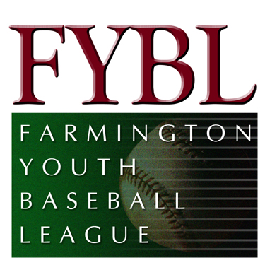Agenda
- Secretary’s Report –acceptance of January 5, 2014 meeting minutes
- Treasurer’s report
- Committee Reports
  - Registration-Byron Frank
  - Marketing- Frank Albert
  - Fields and Facilities- Mike Malario
  - Fund Raising- Mike Mihalek/Vin Bergin
  - Uniforms and Equipment- Mike Mihalek
  - Big Diamond – Gerard Roy
  - Tryouts – Doug Caneday
  - Grouten Donation – Kathy Wolkner
  - Clinics and Coaching – Tom Engle/Dave Conrad
  - Umpire-in-Chief – Terry O’Brien –Rule changes 2014
  - Any others
- Old Business
  - Wine tasting
  - Bylaw Change
  - Workers Comp – Policy to be renewed
- District 5 info-
  - Umpire School March 19-23 in Bristol
  - Softball Coaches Clinic March 8 – one manager or coach
  - ASAP plan is due March 13 – Item #15 write in “uploaded to LL website”
  - District 6 is now in Section 1, New District 12 is added (Sec 2) eastern part of the state
  - Softball inter-league meeting March 6
  - Tournament fees- $1 to $3.00 and cap was removed. $400 to $1500 all other fees stay the same.
- Commissioner Reports
  - Big Diamond –Gerard Roy
  - Softball – Tony Sardilli
  - American – Dave Conrad – Waiver ?
  - National – Mike Malario/Chris Caccamo
  - AAA – Tim MacKenzie – Rule book
  - AA- Byron Frank / John Truhan
  - T-Ball – Byron Frank/John Truhan
- New Business-
  - American League Manager selection
  - Any other new business
- Next Meeting –March 2 , 2014 at Farmington Police Station at 7:00 pm

