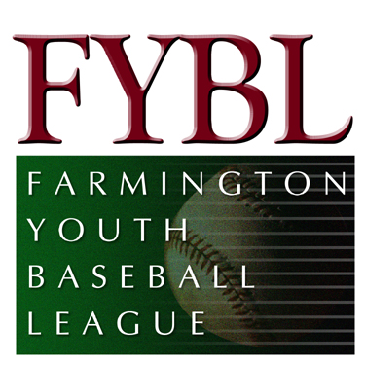Minutes for August Board Meeting

August 11, 2013

Attendees

Aaron Grieco
Alex Kaminski
Byron Frank
Dave Conrad
Doug Caneday
Frank Albert
Jon Wolf
Kathy Wolkner
Larry Green
Matt Guglielmo
Mike Gulino
Terrence O’Brien
Tom Wolkner

- Meeting called to order at 8:08 pm
- Secretary report from July was approved.
- Matt Guglielmo, Treasurer, reviewed the Treasurer’s report for the month of July
Income items included a $1,000 contribution from ESPN (will be used to buy pitching machines) and $2,648 for the Picture Day rebate. Expense items included uniforms ($3,107), umpires for Lindquist ($4,360) and year-end banquet ($2,781).
- Field / Facilities committee
- Cooler in concession stand is now working since it was defrosted.
- Bleachers were fixed.
- Bathroom light is fixed.Men’s
- Tractor – will call other towns to see if they want it
- Lindquist – Avon won the U10 and Watertown won the U12. We need to raise the fees for next year and also market the tournament to the FYBL players. It is a great opportunity to play 8 or 9 games over a 3 week player for the non-district players.
- Fall Ball registration is now available online. FYBL (Larry Green) is organizing the Big Diamond baseball for the Fall (Junior and Senior). D5 is organizing the U9, U11 and Transitional. Contacts from FYBL will be Kathy Wolkner (Transitional), Frank Albert (U9 and U11) and Byron Frank (In-Town).
- D5 is low on funds, expect some additional fees in the upcoming year.
- Meeting adjourned at 9:05 pm.

