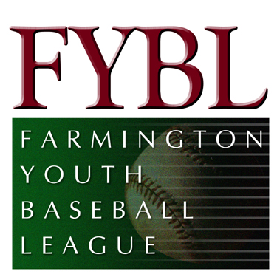Minutes for April Board Meeting

April 7, 2013

Attendees

Bill Collins
Byron Frank
Chris Caccamo
Dan Stepeck
Dave Conrad
Dave Pilon
Doug Caneday
Eric Brouker
Frank Albert
Jon Chaia
Ken Brickner
Larry Green
Matt Guglielmo
Matt McCormick
Mike Gulino
Mike Malario
Rico Chiarillo
Scot Deluca
Scott Sytulek
Terrence O’Brien
Tim McKenzie
Tony Sardilli
Vin Bergin

- Meeting called to order at 7:09 pm
- Minutes for January 27 and March 3 meetings were approved.
- Matt Guglielmo, Treasurer, presented a Treasurer’s report for the month of March.
Revenue
- Registration Fees: $2,020
- Sponsorships: $3,925
Expenses:
Equipment - pitching screens, batting tees, etc. $2,729
Merchandise – senior league practice apparel $1,398
- Dave Pilon addressed the Board regarding some of our insurance issues that have been discussed in prior meetings. He discussed the issues regarding umpires (paid and unpaid), concession stand, and FYBL Appreciation with the bounce house. After a lengthy discussion, the Board authorized up to $1,000 to pay for a worker’s compensation policy for the umpires.
- Coach’s Committee: younger kids clinic has not been scheduled
- Field & Facility Committee: Trash and recycle pick up on Mondays and Fridays, new cooler and freezer for concession stand, painting will be done at the fields, new picnic table, some new billboards were ordered, need shelves for the shed; Bill Collins is trying to sell the tractor
- Marketing: Still need a date for Opening Day; Facebook page is being used; need a newsletter to email to parents; Farmington Patch can also be used
- Safety: Medical kits need to be delivered; Safety Plan sent to Little League
- Kathy Wolkner will help with spring program
- Softball needs a schedule.
- Picture Day is May 11th
- American League will use the dropped 3rd strike.
- Discussion on why we dropped 3 kids from American to National.
- Meeting adjourned at 8:25 pm

