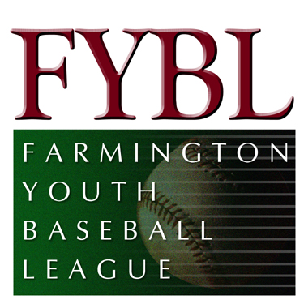Minutes for July Board Meeting

July 8, 2012

Attendees

Bill Collins
Byron Frank
Chris Caccamo
Dan Stepeck
Dave Conrad
David Petroka
Enrico Chiarillo
Frank Albert
Jim Keener
John Calcavecchia
Ken Brickner
Kevin Quigley
Kirt Rasmussen
Larry Green
Matt Guglielmo
Michael Malario
Michael Mihalek
Mike Dunst
Mike Gulino
Peter Rout
Russ Arnold
Tom Engle
Tom Wolkner

- Meeting called to order at 7:10 pm
- Motion made to accept June, 2012 meeting minutes. Motion seconded and accepted.
- Matt Guglielmo, Treasurer, presented the June, 2012 month-end statement. Income from the month included
- Raffle ($15,405) – net figure after expenses
- Contributions ($1,500) – received $500 from Stop and Shop; received $1,000 from ESPN (thanks to Tom Engle)
- Registration ($1,125) – includes additional $225 from Spring registration; $900 from Lindquist registration; additional $9,000 will be collected in July for tournament fees from Lindquist
- Special Events ($2,515) – fees from post-season banquet (will be offset by expenses from banquet)
- Additional $3,000 expected from picture rebate
- Some registration fees are still upaid
Expenses included
- Special Events (($8,547) – includes expenses from 12 year old spotlight, Appreciation Day, Post-Season Banquet and Trophies
- Tournament Fees ($721)
- Umpire Fees ($2,825) – payroll for first half of Spring season
- Uniform ($1,855) – district shirts, team patches and softball all-star uniforms
- Winter Baseball
      - available for 10-12 year olds
      - November to February
      - $100 per child (approximately $7 per week)
      - Need a few managers to run the clinic during the winter
- Commissioners reported on their season from the various leagues; League Champions were
    - American – Royals (Conrad)
    - National – Tigers (Wolkner)
    - AAA – Marlins (Malario)
One suggestion for next year is to start the season a few weeks earlier. We will revisit the issue as we get closer to next Spring.
- All Star results in the Districts
    - 12 year olds: 3-3
    - 11 year olds: 4-2
    - 10 year olds: 2-2
- Lindquist Tournament
    - Fields are in good shape
    - Positive feedback from the Saturday start
    - A few problems with bee stings on the first day
    - Concession stand is open and is supplying water for the umpires.
    - Reminder to keep scoreboard boxes charged.
- Chief Umpire Report – Evaluation of umpires is welcomed. Please drop a note to Mike Gulino with any comments on the umpires.
- Concession stand is open for Lindquist. We will donate the extra food from Appreciation Day to the Concession Stand. $600 bill is outstanding for the propane gas.
- Fall Ball registration will be in early August. We will continue to have a in-town league for AAA and National and travel teams for U-10 and U-12. Byron Frank has volunteered to run the in-house league. Transition league for outgoing 12 year olds has been offered by Babe Ruth ($200 per player).
- Board had a long discussion on the pros/cons of joining Little League for Junior, Senior and Big League. There was a motion which was voted and approved for FYBL to join Little League for the upper levels of Baseball (Junior, Senior and Big League). A commissioner and committee will be appointed to run “big diamond” baseball. Rico Chiarillo and Mike Mihalek will meet with Babe Ruth and FAAC to make sure we have a smooth transition.
- Many thanks to Russ Arnold (12 Year Old Spotlight) and Mike Gulino (Post-Season Banquet) for organizing well run events.
- Tractor shed needs to be cleaned out (especially the food).
- Equipment bags need to be returned. Mike Mihalek will take an inventory over the next few weeks.
- Next FYBL meeting scheduled for July 29 at 7:00 pm
- Meeting adjourned at 8:24 pm

