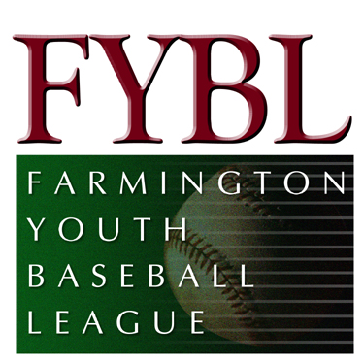Minutes for August Board Meeting

July 29, 2012

Attendees

Bill Collins
Byron Frank
Chris Caccamo
Chuck Welsh
Dan Turkeltaub
Dave Conrad
Enrico Chiarillo
Frank Albert
Jim Keener
Kevin Quigley
Kirt Rasmussen
Kyle Meccariello
Larry Green
Michael Malario
Russ Arnold
Scott Sytulek
Tom Engle
Tony Sardilli

- Meeting called to order at 7:09 pm
- Motion made to accept June, 2012 meeting minutes. Motion seconded and accepted.
- Matt Guglielmo, Treasurer, was not present but prepared the month-end July statement for review by the Board. Based on the year to date figures, we are projecting to be on budget for the year. Income from the month included
- Lindquist Tournament ($9,315)
- Registration Fees from Spring ($285) – additional $1,440 is still due
- Sponsorships ($400) – Dunkin Donuts billboard
- Merchandise ($180) – practice shirts
- Other ($3,381) – picture rebate
Expenses included
- Special Events ($4,704) – includes expenses from 12 year old spotlight, spring program design, post season banquet, medals for softball and additional t-shirts for lower divisions
- Tournament Fees ($721)
- Umpire Fees ($2,825) – payroll for second half of Spring season, Lindquist fees to be paid in August
- Uniform ($9,093) – Lindquist uniforms, district uniforms/pants/coaches shirts, softball uniforms; district uniforms will be reused for next year
- Equipment ($1,378) – pitching rubbers, baseballs for Fall Ball, and batting tees
- Fields Committee
      - 12 bags of Turface and Lime will be needed for Fall Ball
      - Urinal handle is broken
      - Softball championship billboard to be ordered and placed on Baily field in the Spring, 2013
      - Electric hand dryers for bathrooms, possibility for next year
      - Bathroom cleaning responsibility is still an issue
- Tournament Reports
    - 10 year olds won the West Hartford tournament with and 8-0 record
    - 12 year old are currently 2-2 in the Southington tournament
    - 10 year old Lindquist finished 2-7
    - 12 year old Lindquist made it to the finals and lost in the championship game 13-2 to New Hartford; great job!!!
    - Softball – 10 year olds made it to the Sectionals and finished 1-3, but was a great experience for the entire team
- Kyle Meccariello and Dan Turkeltaub were present for a discussion of the transition of “big diamond’ baseball from Babe Ruth to FYBL. For the Fall Ball season, all teams (Transition and Junior League) will be under the umbrella of Babe Ruth. Starting in the Spring 2013, FYBL will offer Junior, Senior and Big League baseball. A VP of “big diamond” baseball will be named and a committee will be formed to run these leagues (similar to what we do for softball). Fees for Fall Ball are $200 which pays for umpires, uniforms and equipment.
- Next FYBL meeting scheduled for August 26 at 7:00 pm
- Meeting adjourned at 8:00 pm

