Welcome....
For the 2015-2016 season there are approximately 1,350 girls and boys participating in our programs. We pride ourselves on creating an enjoyable experience for all youths by developing sportsmanship, integrity, and a solid foundation on the rules of the basketball game. This is all built on our motto of Together We are One.

Recent News

- Follow us on Twitter!!

- Next Meeting will be July 12th - 7:30p @ Limerick Township Building

- Check out our new Sponsorship programs

- Registration will be opening in August

- Roland Olsen - New SFYB President

Welcome Letter

I hope everyone is enjoying a beautiful start to the month of May. I’m sure many of you are in full swing with spring sports and your minds are far from the sights and sounds of the winter basketball season. For the Board of SFYB, the 2015-16 season is already fast approaching and there is much to be done before registration opens in August.
At the top of our to-do list is adding to our ranks of volunteers. I can tell you first hand that too much is falling on too few people. For an organization which supports almost 1400 kids, our organization is significantly undermanned/underwomaned. In the 8+ years I have been involved with SFYB, I have seen the same very limited number of people attending league meetings and participating as commissioners, coaches and project coordinators. It is time for us to get new people involved and to a much greater effect.
I am sure there are plenty of you out there reading this saying “I would love to help, but I don’t know anything about basketball.” There are quite a few people out there who’ve seen me coach that would contend I don’t know anything about basketball either, but that hasn’t kept me from being elected as President! There is plenty to do and lots of opportunities to help outside the basketball court which will greatly benefit our kids and organization. So, if you are a spreadsheet wizard, a webmaster, a strong organizer, or just a get-it-done type person, we can use your help. Here are some of the roles that we need filled:
1) VP of Operations (Board position)
2) Assistant VP of Operations
3) VP of Marketing (Board position)
4) Assistant VP of Marketing
5) Assistant Treasurer
6) Assistant Secretary/Registrar
7) Referee Coordinator (Rec & Travel)
8) Asst. Head of Referees/Head of Youth referee training
9) League webmaster
10) Assistant League webmaster
11) Master Gym Scheduler
12) Assistant Gym Scheduler
13) Rec League Uniform Organizer
14) SFYB President’s Day Tournament director (very tough shoes to fill)
15) Assistant Tournament Coordinator
16) Adult Volunteer Recruiter and Coordinator
17) Youth Volunteer Recruiter and Coordinator
18) Coach Development Coordinator
19) Director of Player skills development/clinics
Lastly, and most importantly, I would like to personally thank our outgoing Board members for their service to our organization. Thanks to Cindy Begg (VP of Marketing) who implemented a sponsorship program, spirit wear and the Dick’s Sporting Goods discount day that everyone loves. I really only had a chance to work directly with our outgoing President, Kevin Kovaleski, and VP of Operations, Matt German, over the last year or so and I can assure you that SFYB is better today than when they began their tours of duty, a tour which comprised hundreds of thankless hours executing on the tasks necessary to make SFYB the class of youth basketball organizations in our area. Many kids and families, including the Olsens, have benefited greatly from the service of these Board members and they’ve set a high bar for those of us who follow. Thank you!
My hope is that I, and future Presidents, have the opportunity to express many a thanks to a long and distinguished list of fellow volunteers going forward. We look forward to receiving your emails of interest in helping out soon - please send them to our Board Secretary, Cindy Dengler, at cld@fmurphylaw.com. Reference the number and role from the list above that you are interested in to help us fill our immediate needs.
Thanks,
Roland

Annual Spring-Ford Basketball Tournament
73 Teams of Exciting Action!

The Annual Spring-Ford President's Day Tournament was held over the holiday weekend and saw more than 70 teams competing at different levels. The Spring-Ford School district gyms were filled with players and fans, some traveling a few hours to participate. The games were exciting and intense, with some going into many overtime periods. The weather was on the cold side but the games were "heated" as there was great basketball being played.

Thanks to all our volunteers, especially Roland Olsen, the Tournament Director, who spent many hours in varying responsibilities to make the tournament a success. Also, thanks to all the teams for participating and we hope to see you next year.

Below are some pictures captured from the tournament.
10U Champs
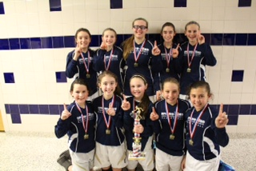

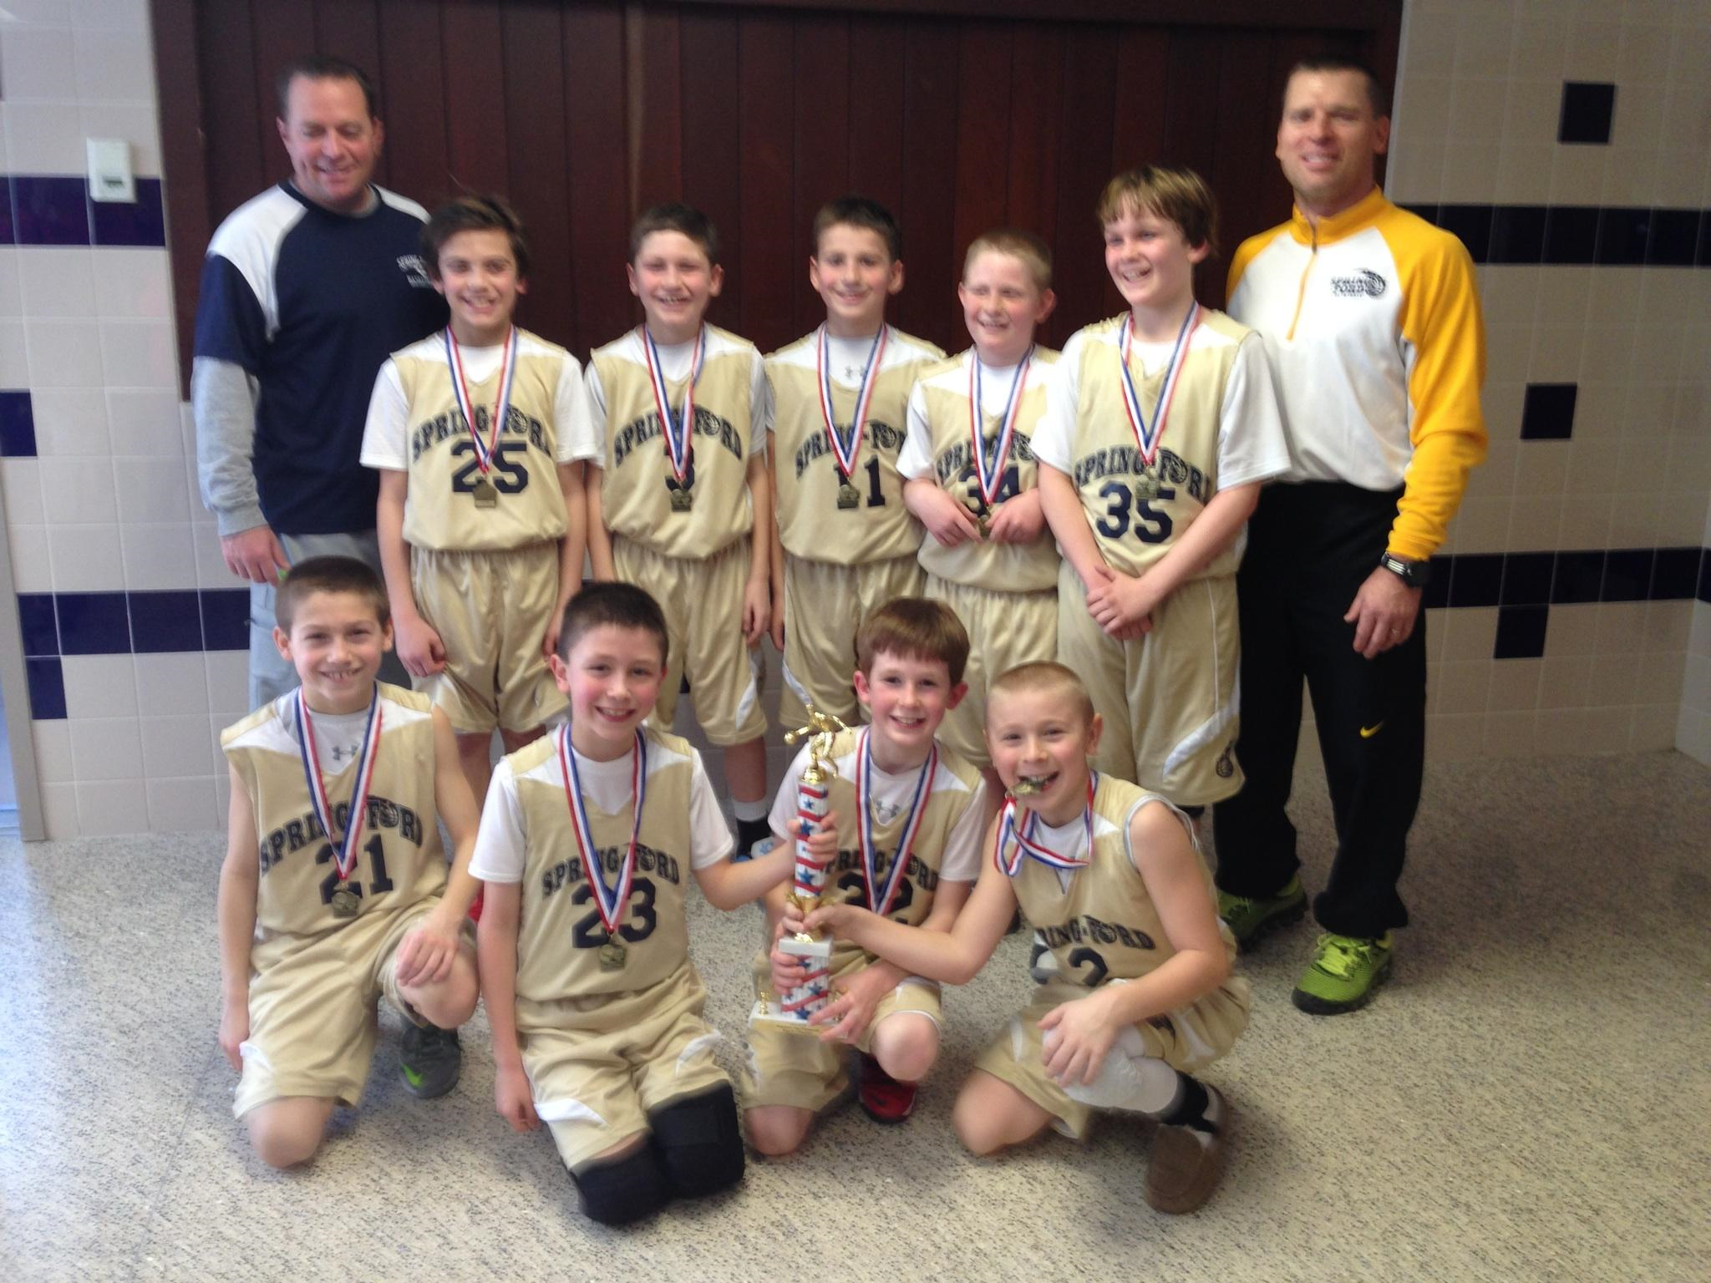

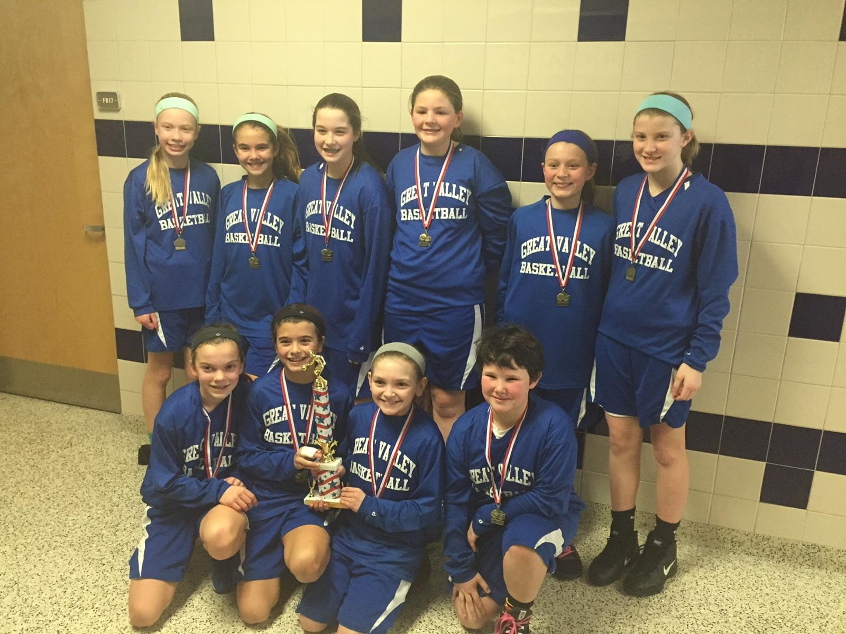

Spring-Ford 8th Grade Travel Team
at the Wells Fargo Center
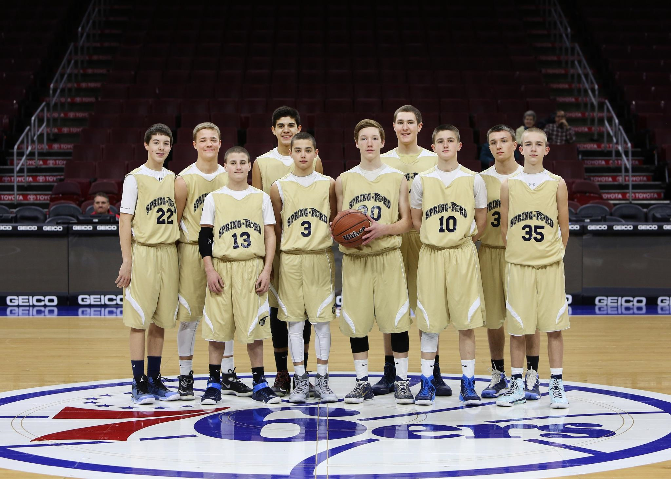

The Spring-Ford 13U Travel Team played at the Wells Fargo Center recently. It was a very special night for all the players and something they will remember for years to come.

Gym/Parking Reminders:
Please remember the following gym and parking rules for our spectators and players. These need to be strictly adhered to:
Gym Rules:
1) No outside basketballs allowed. Only league distributed basketballs can be used on the courts
2) No food or drink is allowed to be brought in.
3) No sitting allowed on bleachers that are stowed away. This mainly applies to the Rec games at the 7th grade center.
Parking Rules:
1) Only park in designated spots. If the parking lot is full at the 7th grade center, there is parking behind the building
2) Do not park in handicapped spots unless you have a handicap tag
3) Do not park in Fire Zones.
Please be aware that the local police department will be patrolling the area and tickets will be given out for violations. We are guests of the Spring-ford School District.

Coaches Quick Links
Practice Plans
Grades 1-4
Grades 5-8

2014-2015 Travel Rosters
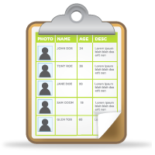

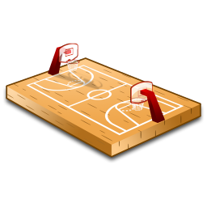

Featured League Sponsor

Note: keep in mind that no refunds will be issued after October 1. After October 1 no registration fee refunds will be issued. Additionally, all registration fees will need to be submitted via credit/debit card - no personal checks.

