TWO RIVERS YOUTH CLUB
PLAYER REGISTRATION PROCESS

Introduction: For the 2013 season, TRYC is introducing online registration for parents. This will take the place of the parent release forms, code of conduct forms, and numerous hand written roster related forms that have been used in the past. We hope that this new process makes it easier for coaches and for parents to register their child(ren) to play at TRYC. It will also facilitate better communication from the league to both coaches and parents.

Purpose: The purpose of this document is to provide Coaches with information regarding the TRYC website to allow them to perform the following tasks:
- Player Registration.
- Print a roster.
- Utilize other website features for their teams.

1. Instructions for Player Registration

a. After team registration, your team name and coach will be entered on the TRYC website by a TRYC representative in the appropriate division.
b. Coaches will be e-mailed a link along with instructions to forward to their parents (Parents SHOULD NOT USE the Register Now button on the home page of the TRYC website – this is for
players looking for teams and will not allow you to select the team you play for).

If the coach has a player on his/her team that was assigned to them through the player pool, this child will already be registered in the system. They do not need to register again. Please contact your division manager and they will be able to transfer that player from the pool to your roster.
c. The link the coach forwards to his/her team will send parents directly to the Team's specific division registration (below is the example from the Colt division).

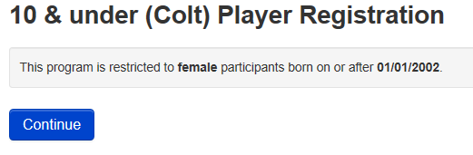
If parents have children playing in more than one division, they will receive separate links for each division.

d. Once the parent hits the continue button above, they will be taken to a sign in screen. Parents will need to set up a member account on the TRYC website. They will enter an e-mail address and the system will send them a temporary password to be used to login.
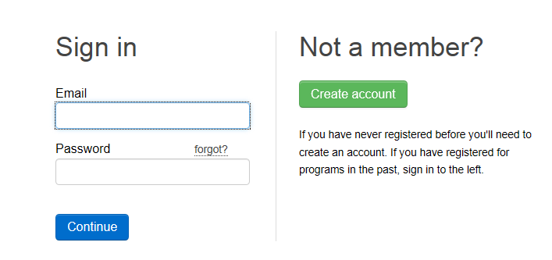

e. After the parent has created a member account, they may use the link to enter the registration form. After the parent's information has been submitted, you will be able to add a child.
f. Parents should complete the required information as follows:

Participant Information:
Complete Name, Address, and Phone Number information. Make sure to complete cell phone information and whether you wish to receive text messages. TRYC will be able to text game cancellations and urgent messages directly to your cell phone. Address and at least one phone number should be selected as roster so it will appear on the team's roster. PLease DO NOT select Public for any of these items as they will appear for anyone visiting the TRYC website. Click button.

Supplemental Information:
After clicking the Submit button, additional information is required.
- Please select the team your child will play for during this Season.
- Please indicate whether you would be able to volunteer for TRYC.
The Two Rivers Youth Softball Club is run by a number of volunteers who are dedicated to providing a great softball experience. If you want to have a greater impact, please consider volunteering in the league as a coach, tournament committee member, division manager, asst. coach, ticket taker, sponsorship support or Board member. Please select from the volunteer list below

- Please read the coach, player, and parental release agreement and code of conduct and check the box acceptance box.

Click the box.

2. Instructions for monitoring and printing roster.

Once all of a coach's players have registered, he/she should be able to go to the team's webpage and print a roster. This roster should be taken to player registration. This will serve as the team's official TRYC roster. No other roster is required for league play.

To print their team's roster, coaches should;

a, The coach should be able to monitor which players have registered on his/her team's home webpage (the coach must log in with his/her user id and password). After entering the team's webpage, select the roster menu item.
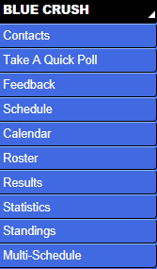

Detailed roster information such as the child's name, address, birthdate, phone number, and e-mail should only be visible to the specific team's coach(s). Individuals outside the team coaches will only see the players first name and last initial.

b. On the roster page, select the Options drop down and then select print roster.

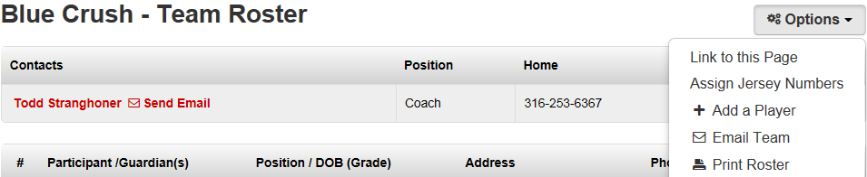

c. For player registration, bring the following items:
- printed roster from the TRYC website.
- players birth certificates.
- team payment.
- proof of background check.

3. Other Website Features.

Each team will have it's own page on the TRYC Website. To enter a team web page, under the Team menu item, select your specific division and your team. Current features that can be utilized by coaches and parents include:
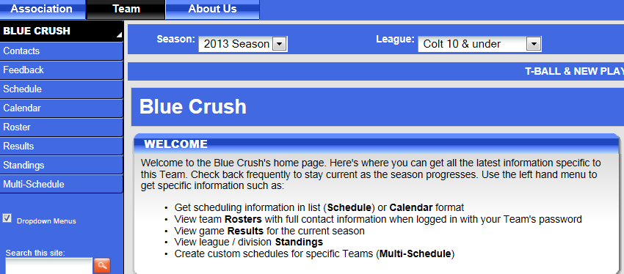
a. View and print out a specific team's schedule or multiple team schedules.
b. View team game results and Standings.
c. Add team bulletins to communicate messages, special practice or game information, etc. that can be viewed by members of your team.
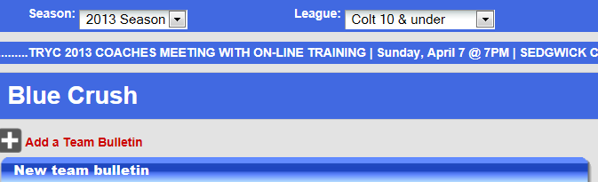
We hope this process makes it easier on both coaches and parents to register their children, receive important communication from the league, and receive timely schedules and standings. If you or one of your parents has a question or suggestion related to the website or the registration process, please contact your division manager. Have a great season!

THANKS FOR PLAYING AT TRYC!!!

