

FRIDAY, May 18th 2018

8:30 am registration

9:00 am start

Willow Brook Golf Course

124 Brookfield Street

South Windsor, CT

**Judicial Professional Employees Union**



During the tournament, 4 par 3’s with a JBC tee-sign has a hole-in-one prize.

The hole-in-one prize is a fabulous 5-day/4-night golf vacation package for two people to any one of our JBC resorts In addition, this vacation package includes round-trip airfare provided by JetBlue Airways as part of the hole-in-one prize.

[**www.jetbluechallenge.com**](http://www.jetbluechallenge.com)

**Check out the scorecard for this fun and easy playing course!**

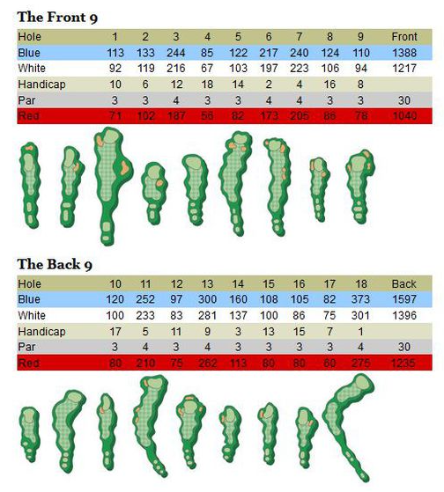

The Connecticut Section PGA announced that Willow Brook Golf Course in South Windsor, Conn., has been named the 2014 recipient of the Walter Lowell Public Golf Course Distinguished Service Award, as the model public golf course serving the game of golf in Connecticut and Western Massachusetts. The award was inaugurated in 2001 in honor of Canton Public Golf Course for the standards it set towards a public course’s responsibility to its community to provide playing opportunities for all those who want to play and learn the game.

JPE has selected this course for the Terry P. Ward Memorial Scholarship Tournament as a testament to Terry and his kind and gentle ways. Willowbrook is a course that is fun and playable for all types of golfers. Whether male or female, young or old, seasoned golfer or new at the game, Willowbrook will provide all those who participate a great tournament experience.

Please join us on May 18th. All proceeds will benefit the Terry P. Ward Memorial Scholarship Fund. We look forward to enjoying the day with you!

**www.willowbrookgc.com**

# 4th Annual

# Terry P. Ward Memorial

# Scholarship Fund

# Golf Tournament



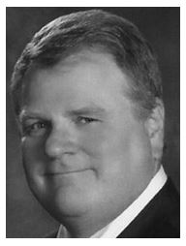

In memory of our friend and colleague. We miss you Terry. Your energy and spirit cannot be replaced. Go Gamecocks!



***Tournament Highlights***

***ONLY 72 GOLFERS (REGISTER EARLY!)***

***REGISTRATION INCLUDES . . .***

***GOLF, DRIVING RANGE, GIFT BAG, BREAKFAST, LUNCH, 1 YEAR SUBSCRIPTION TO GOLF DIGEST or GOLF WORLD MAGAZINE, AND ALL ON COURSE BEVERAGES!***

***CONTESTS***

* ***LONG DRIVE***
* ***CLOSEST TO THE PIN***
* ***4 HOLE-IN-ONE TRIPS WITH AIRFARE***

***WINNING TEAM WILL RECEIVE . . .***

***$100 gift certificates & names on tournament plaque!***

***PRIZES FOR THE 2nd and 3rd PLACE TEAMS TOO!***

**Sponsorship Levels**

**Supreme Sponsor $2000.00**

This is the event’s highest level of sponsorship! This package includes two foursomes, Tee Sponsorship on Hole #1, Placement on the Program Cover and a Full Page Program Ad, Listed with winning foursome on tournament plaque and special recognition during the award & prizes presentation.

**Appellate Sponsor $1000.00**

This package includes one foursome, Tee Sponsorship on Hole #2, Full Page Program Ad and special recognition during the award & prizes presentation.

**Superior Sponsor $500.00**

This package includes one foursome, Tee Sponsor on Hole #3 and a Program Ad.

**Tee Sponsor $125.00**

Have your business, office, agency or family message on the course throughout the event. You may choose the Hole number of your choice other than Hole 1, 2, or 3. Acknowledgment in the tournament program.

**Program Ad $75.00**

Each golfer will receive a complimentary gift bag. Each bag will contain an event program. Have your business, office, agency or family message seen by all those who participate in the event.

Please call 860.303.3524 for more information on Sponsorship opportnities.

Raffle prize donations are also appreciated.

*The Terry P. Ward Scholarship Fund’s tax status as a 501C(3) charitable organization is pending approval from the IRS*

#### Tournament Information and Registration

#### $99.00 per golfer

#### $380.00 per foursome

#### 8:30 am Registration and Putting Contest. Driving Range will be open. Each Golfer will receive a bucket of balls

#### Coffee, Doughnuts and Muffins will be provided

#### 9:00 am “Shotgun” Start. “Scramble” tournament play format. ALL players will tee off from the WHITE tees.

#### On Course Beverages provided by Marshall*law* LLC

#### 12:00 Lunch, Prizes, Awards and Thank You!

#### -----------------------------------------------------

#### Registration

#### Golfer 1 (Captain)

#### _______________________________

#### Email __________________________

#### Golfer 2 - ______________________

#### Golfer 3 - ______________________

#### Golfer 4 - ______________________

#### Single or Partial Groups Welcome. Partial Groups will be combined with Singles.

#### Mail Checks payable to :

#### T.P. Ward Memorial Scholarship Fund

#### c/o Judicial Professional Employees Union

#### 50 Columbus Blvd. 3rd flr.

#### Hartford, CT 06106