Dracut Youth Lacrosse Shooter Shirt
$40
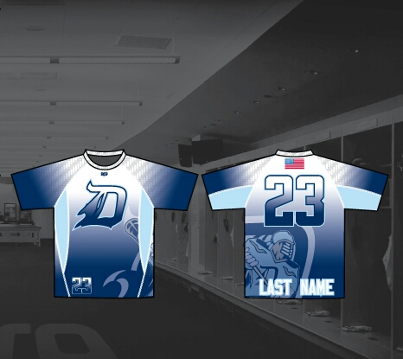

Name_______________________________________________

Team_______________________________________________

Number_____________________________________________

Size________________________________________________

Paid________________________________________________

*Sizes run a little on the smaller side as it’s a shooter shirt that goes under equipment

