SHARON BOY’S LACROSSE HELMET INFORMATION

Brand - Cascade R.
Visor - Old Gold Shell - Old Gold
Chin - Maroon Mask - Gold Chrome Chin Strap - White

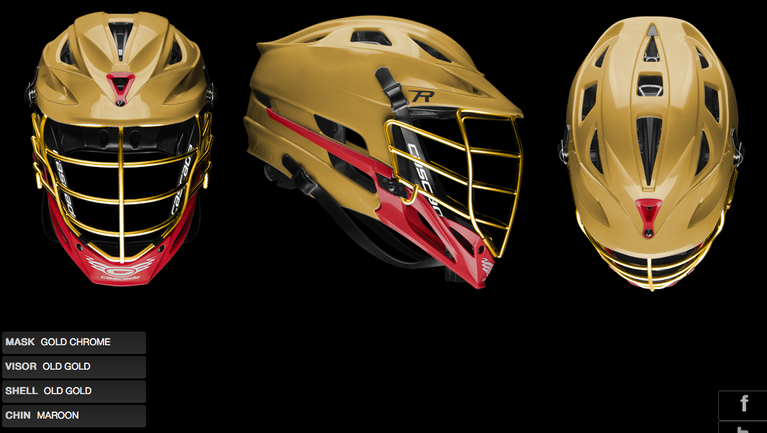

Contact information for the sales rep: Ryan Murphy ryanm@atlanticsportswear.com

