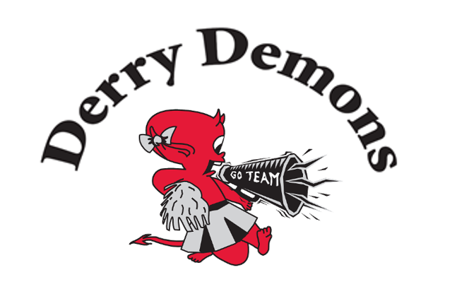

Derry Football Association 2016 Cheer Camp Fundraiser
Divisions 8-12

2016 Cheer A Thon
Date: Sunday, June 5th
Time: Ages 7-8 9AM-11:45 AM
Ages 9-10 1PM-4PM
Ages 11 and Up 9AM-4PM
Location: Pinkerton Shepard Building
Cost per Athlete - $5

Cheer Camp Info
UCA Cheer Camp
Dates: July 29-31st
Times: More info will follow
Cost per Athlete:
      - Sleepover Athlete: $225
      - Commuting Athlete: $185
      - Sleepover Coach: $185
      - Commuting Coach: $145

In order to offset the costs of camp, athletes may participate in a Cheer-A-Thon Fundraiser to be held at Pinkerton Academy on June 5th. The athletes will ask for donations as they cheer for all or part of the day (see attached donation form).
- Any monies raised by the athlete will go toward their OWN cost of camp.
- If they raise UNDER the total, they will be responsible for the remainder of the cost.
- If they raise OVER the cost, the funds will go into a pool to assist other camp participants from the Demons.
- Any TOTAL surplus (if all athletes raise above their costs) will go into the general fund.
- Camps are not mandatory, but they are encouraged.
- If an athlete does not attend camp, they will still need to purchase required apparel.

Athlete Signature: Date:

Parent Signature: Date:

