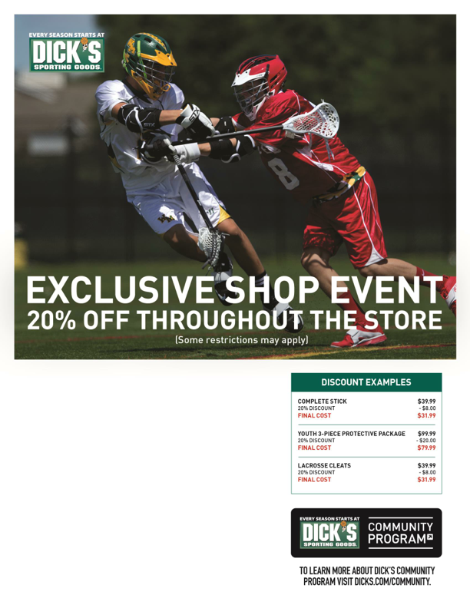
Stop by the check-in table to receive discount details!
Valley Mall
1925 East Market Street Harrisonburg, VA 22801 540-433-1268
SATURDAY, February 22nd 11:00AM – 4:00PM
