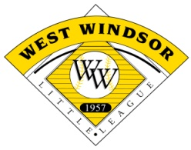
West Windsor Little League Sponsorship Registration Form
Company Name:
Contact Name:
Mailing Address:
City, State, Zip:
Telephone:
Fax:
Email:
Website: | www.
League | Amount
Tee Ball | $225
Rookie Baseball | $325
Rookie Softball | $325
AAA Baseball | $375
Minors Baseball | $450
Minors Softball | $450
Majors Baseball | $450
Majors Softball | $450
OUTFIELD SIGN :  Assist America, Wasco or Kelly Field | $400
Sign on ALL Three Fields | $1000

Sponsorship Program Selection

 | Amount | League/Field  Requested
Team Sponsor
Outfield Sign: Qty x $400
Donation
Total:

Please make checks payable to:

West Windsor Little League, Inc.
P.O. Box 324
Princeton Junction, NJ 08550

You may also sign up for sponsorships at www.wwll.org

