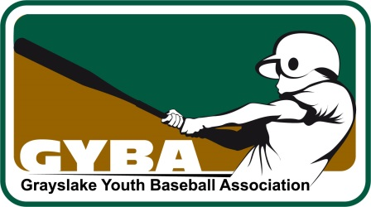 Grayslake Youth Baseball Association
________________________________________________________________

Grayslake Youth Baseball

David G Peregrin Scholarship

Deadline: April 6th, 2015

A $2,500.00 scholarship will be awarded to a Grayslake Community High School District 127 *senior (Class 2015) who plans to further their education at an institution of higher learning immediately following graduation. This award is limited to senior varsity softball and baseball players.

Applicants must submit the following

- Completed cover sheet with Counselor’s signature.
- Typed personal statement on your career goals.
- Proof of acceptance (or proof of application if acceptance has not yet been received) to college or university of choice.
- List of school and community activities, including all leadership positions. Be Specific on involvement and personal contributions.
- Official sealed academic transcript (based on 7 semesters)
- Completed Applicant Recipient Certification.
- Proof of lettering in varsity softball or baseball from Athletic Director.
- Candidates must make themselves available for a personal 20-minute interview with Scholarship Committee.

Selection will be based on individuals who have demonstrated exemplary leadership and life skills, through civic and community activities, academic excellence, and the fulfillment of the “TEAM” commitment.

*The Scholarship Foundation Committee reserves the exclusive right in determining the individual / individuals recognized for this award. In the event the committee recognizes that more than one candidate is deserved of this award, the monetary amount issued will be divided equally.

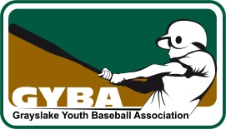
The Grayslake Youth Baseball Association
David G Peregrin Scholarship

Cover Sheet

Name:

Address:
Phone: __________________
Colleges/Universities to which you have been accepted:

Designated Major (if decided):

Athletic Sports and year played while in High School:

List school and community activities including all leadership positions:

Student Signature/Date:

Counselor Signature/Date:

We strongly recommend attaching additional pages of background information to this document. Upon completion, return all material to your Guidance Counselor by April 4th, 2015.

Please return all documents with attachments.

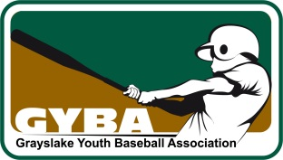

Scholarship Recipient Certification

- I, do hereby certify to the
Grayslake Youth Baseball Association, and agree to the following:

- I am a graduate of Grayslake Community High School District 127.

- I have been accepted to (college or
University) and will attend this college /university in the Fall of 2015.

- I agree that the scholarship amount of $2,500.00 or any awarded amount will be used to supplement tuition; credit hour costs and books only.

5. I agree that the check issued for the scholarship funds shall be issued jointly
to the recipient and recipient’s college or university.

6. I agree to supply to the GYBA (Grayslake Youth Baseball Association),
within six (6) months of the scholarship funds, receipts or other documentation
certifying that the scholarship funds were used to pay for items described in # 4
above.

- If I fail to provide the above receipts or other documentation to GYBA, I
agree to refund to the Grayslake Youth Baseball Association (GYBA) the
amount I have received as the recipient of the GYBA David G Peregrin
Scholarship Award.

- The GYBA may publicize, in print or other media outlets, that I am the
recipient of the GYBA David G Peregrin Scholarship Award for 2015.

- The award will be announced at the respective schools Honors Night.

S Signature

((Please Print Name)

Date

