Minutes of the CHC Board of Directors Meeting, December 14, 2010

CALL TO ORDER

ROLL CALL
Directors Present: All except: East Haven, Gr. Bridgeport, Kent, Middlesex. Northwestern, Pawling, , Salisbury, Simsbury, Stamford, and Wallingford.

Board Officers Present: President, Tom Regan, Vice President Gerry Rasmussen; Secretary: Glenn Van Moffaert; Treasurer, Michael Federico.
Other CHC officials (non-voting) present: Eligibility Chairperson and District-I Commissioner, Kathy Ludwig; District-IV Commissioner, Glenn Van Moffaert; Women and Girls Director, Joe Dmarzcyk; Tournament Director, Brian Oatway, Squirt Director, Rich Dibble;; Midget Director, Art Blakeslee; Bantam Director: Amy Landino; Open Division: Rob Polo; Grow the game: Ken Dixon.

ACCEPT THE MINUTES
The November minuets were approved.

NEW BUSINESS
A proposal for a preseason evaluation period prior to declaration was tabled since Bob Fielder (Enfield) was absent.

ADM Conference: Scott Miller gave an upbeat and encouraging report of the Chicago ADM Conference. At the Conference, discussion was made whether improper checking technique is a cause for injury. There is suggestion to remove checking from PeeWee and start in BA, with an enhanced program to teach proper skills at the Sq age. Tom suggested to invite Roger Grillo to the January meeting to discuss the issue of checking, and the progression of the ADM.

OLD BUSINESS
Tom presented three new policies for the Board’s consideration: CHC Records Retention Policy; CHC Whistleblower Policy; and CHC Conflict of Interest Policy. Glenn commented that minor tweaks are necessary to ensure that the CHC would be able to comply with the new standards. Some of these edits would be to remove instances of the word “employee”, as CHC does not have employees in its organization, as well as carve out requirements to retain emails not generated through a CHC operated system.
A Motion (seconded) was made to accept the policies as amended provided that the Executive Committee give their concurrence to the amendments. The Motion PASSED by a unanimous show of hands.*
*(Post meeting note: The Executive Committee reviewed and approved the aforementioned Policies as amended).

REPORTS

President. Tom Regan advise d that January will be the month to present items for initial consideration to amend the Bylaws. Tom also reported that an outside audit of the CHC was made, and praised Mike Meakem and Mike Federico for their time and ability to answer all questions of the auditors. Our books and procedures are in excellent condition.

Treasurer. Mike Federico handed out consolidated balance sheets of the finances for CHC; the organization is healthy. Mike also advised that the matching dollar program to support local Grow-the-game initiatives is made on a per season basis, and not for a calendar year.
Secretary Glenn reported that the petition of the Putnam Panthers to join CHC is still open for consideration by the BOD. The Panthers have been playing games with CHC programs in Open Division. The original petition nobly Putnam is made as an attachment to these minutes. For the January Meeting, representatives of the Putnam organization will be present to answer questions from the Board. If their petition is granted, then amendment to the Bylaws is necessary.

Tournament Committee Brian noted that seeding for the Tournament will be made at the end of January. Any “special requests” may be considered only for the Open Division.
Festival Ice: Ice sheets were obtained that provide a convenient radius of travel of about 20min. Placement for Girls’ tourney is still being decided.
Volunteers are needed to the Midget T-1 tourney at Simsbury in April.
CORRECTION: For Squirt (T2) PeeWee, only FOUR teams advance [previously reported that 5 teams advance]

Bantam Division: Amy reported that a change to T2 format will be made soon. Imporperly filled out scoresheet remain a problem, especially with timeliness of submitting to the committee chairs. The winning team is responsible to mail in the sheet within 5 days of the game.

Eligibility Committee (Kathy Ludwig). Sadly, Coach profanity railed to referees is escalating to the MT and SQ level.
Remember that period length matters for age groups. Follow the prescribed guidelines. At BA, for example, it is 16’ periods…to accommodate a 45min reserved time, the first two periods are played 16’ and then adjust the final period accordingly.
Please be mindful of High-school age player movement.

Commissioners. Penalties continue to rise.

Woman’s Hockey (Joe Dmarzcyk) Festival tryouts will be posted for first w/e in February. So far only 20 have signed-up.

Coaching Education Program See web for time/locations for L1/L2 seminars – last one is in December! Remember, only two levels can be certified in any one year, however a temp card MAY be issued if applied for.
Grow the Game: Ken reported on the good success of “Gotta Love CT Hockey”. Considering to report on one of the outdoor rinks in light of the success the NHL has with its “winter classic”.

MOTION TO ADJOURN
A Motion to Adjourn (seconded) PASSED by unanimous voice vote.

NEXT MEETING: January 25 2011
7:30pm
Italian American Club
35 Chase Lane, West Haven.
Putnam Panthers

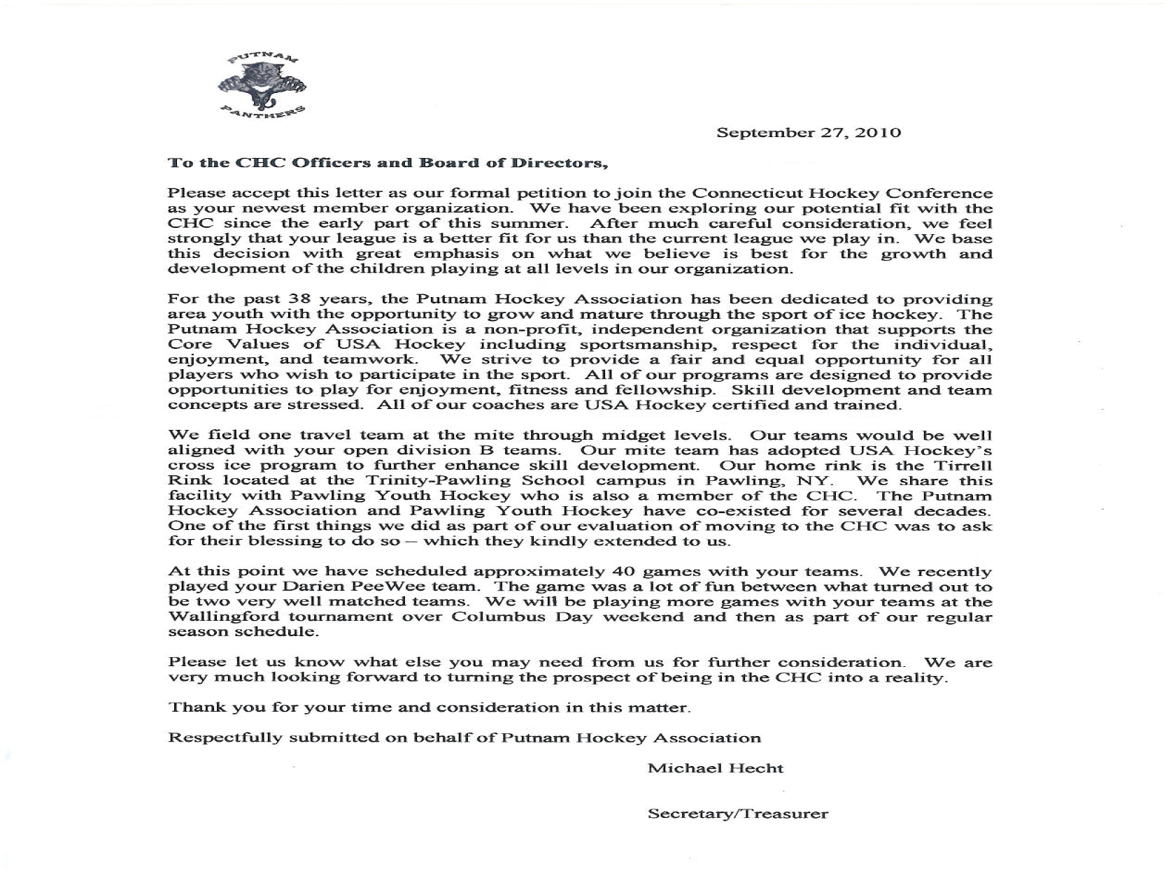

CONNECTICUT HOCKEY CONFERENCE
WHISTLEBLOWER POLICY

- Purpose

The Connecticut Hockey Conference (CHC) requires board members to observe high standards of business and personal ethics in the conduct of their duties and responsibilities and for all to comply with all applicable laws and regulatory requirements.

- Reporting Responsibility

CHC seeks to have an “Open Door Policy” and encourages board members to share their questions, concerns, suggestions or complaints regarding the organization and its operations with someone who can address them properly. In most cases, a board member should present his or her concerns to the CHC President. The CHC President is generally in the best position to address an area of concern. However, if a board member is not comfortable with the CHC President’s response, is not comfortable speaking with the CHC President, the board member is encouraged to speak with anyone on the Board whom he is comfortable in approaching or to directly contact an outside legal counsel.

- No Retaliation

No board member who in good faith reports a violation of a law or regulation requirement shall suffer harassment, retaliation or adverse consequence to their standing as a board member. This Whistleblower Policy is intended to encourage and enable persons to raise concerns within the organization prior to seeking resolution outside the organization.

- Compliance Officer

The CHC President will act as the CHC’s Compliance Officer. The Compliance Officer is responsible for investigating and resolving all complaints and allegations concerning violations of the Purpose. The CHC Vice President will take on the Compliance Officer role if the complaint involves the CHC President. If the complaint involves both the CHC President and CHC Vice President, outside legal counsel will carry out the functions of the Compliance Officer.

- Accounting and Auditing Matters

The Finance Committee of the Board of Directors, which shall include the President, Vice President, and Treasurer shall address all reported concerns or complaints regarding corporate accounting practices, internal controls or auditing. The Compliance Officer shall immediately notify the Finance Committee of any such complaint and work with the committee until the matter is resolved.

- Requirement of Good Faith

Anyone filing a complaint concerning a violation or suspected violation of the law or regulation requirements must be acting in good faith and have reasonable grounds for believing the information disclosed indicates a violation. Any allegations that prove not to be substantiated and which prove to have been made maliciously or knowingly to be false will be viewed as a serious disciplinary offense.

- Confidentiality

Violations or suspected violations may be submitted on a confidential basis by the complainant or may be submitted anonymously. Reports of violations or suspected violations will be kept confidential to the extent possible, consistent with the need to conduct an adequate investigation.

- Handling of Reported Violations

The Compliance Officer or person responsible for carrying out the Compliance Officer’s role with respect to a reported or suspected violation will acknowledge receipt of the reported violation or suspected violation by writing a letter (or email) to the complainant within five business days. All reports will be promptly investigated and appropriate corrective action will be taken if warranted by the investigation.

CONNECICUT HOCKEY CONFERENCE

CONFLICT OF INTEREST POLICY

SECTION 1. PURPOSE:

The Connecticut Hockey Conference (“CHC”) is a nonprofit, tax-exempt organization. Maintenance of its tax-exempt status is important both for its continued financial stability and for public support. Therefore, the IRS as well as state regulatory and tax officials view the operations of CHC as a public trust, which is subject to scrutiny by and accountable to such governmental authorities as well as to members of the public.

Consequently, there exists between CHC and its board and officers and the public a fiduciary duty, which carries with it a broad and unbending duty of loyalty and fidelity. The board and its officers have the responsibility of administering the affairs of CHC honestly and prudently, and of exercising their best care, skill, and judgment for the sole benefit of CHC . Those persons shall exercise the utmost good faith in all transactions involved in their duties, and they shall not use their positions with CHC or knowledge gained for their personal benefit. The interests of the organization must be the first priority in all decisions and actions.

SECTION 2. PERSONS CONCERNED:

This statement is directed to directors and officers, and any other parties who may play a role in the organization’s management. For example, this would include all who make purchasing decisions and anyone who has proprietary information concerning CHC.

SECTION 3. AREAS IN WHICH CONFLICT MAY ARISE:

Conflicts of interest may arise in the relations of directors and officers with any of the following third parties:

1. Persons and firms supplying goods and services to CHC.
2. Competing or affinity organizations.
3. Donors and others supporting CHC.
4. Agencies, organizations. and associations which affect the operations of CHC.
5. Family members, friends, and other employees.

SECTION 4. NATURE OF CONFLICTING INTEREST:

A conflicting interest may be defined as an interest, direct or indirect, with any persons or firms mentioned in Section 3. Such an interest might arise through:

1. Owning stock or holding debt or other proprietary interests in any third party dealing with CHC.

2. Holding office, serving on the board, participating in management, or being otherwise employed (or formerly employed) with any third party dealing with CHC.

3. Receiving remuneration for services with respect to individual transactions involving CHC.

4. Using CHC’s time, personnel, equipment, supplies, or good will for other than CHC -approved activities, programs, and purposes.

5. Receiving personal gifts or loans from third parties dealing or competing with CHC. Receipt of any gift is disapproved except gifts of a value less than $50, which could not be refused without discourtesy. No personal gift of money should ever be accepted.

SECTION 5. INTERPRETATION OF THIS STATEMENT OF POLICY:

The areas of conflicting interest listed in Section 3, and the relations in those areas which may give rise to conflict, as listed in Section 4, are not exhaustive. Conflicts might arise in other areas or through other relations. It is assumed that the directors and officers of CHC will recognize such areas and relation by analogy.

The fact that one of the interests described in Section 4 exists does not necessarily mean that a conflict exists, or that the conflict, if it exists, is material enough to be of practical importance, or if material, that upon full disclosure of all relevant facts and circumstances it is necessarily adverse to the interests of CHC.

However, it is the policy of the board that the existence of any of the interests described in Section 4 shall be disclosed before any transaction is consummated. It shall be the continuing responsibility of the board and officers to scrutinize their transactions and outside business interests and relationships for potential conflicts and to immediately make such disclosures.

SECTION 6. DISCLOSURE POLICY AND PROCEDURE:

Transactions with parties with whom a conflicting interest exists may be undertaken only if all of the following are observed:

1. The conflicting interest is fully disclosed;
2. The person with the conflict of interest is excluded from the discussion and approval of such transaction;
3. A competitive bid or comparable valuation exists; and
4. The board or a duly constituted committee thereof has determined that the transaction is in the best interest of the organization.

Disclosure in the organization should be made to the President (or if she or he is the one with the conflict, then to the Vice President), who shall bring the matter to the attention of the Board of Directors. The Board of Directors shall determine whether a conflict exists and in the case of an existing conflict, whether the contemplated transaction may be authorized as just, fair, and reasonable to CHC. The decision of the Board of Directors on these matters will rest in their sole discretion, and their concern must be the welfare of CHC and the advancement of its purpose.
CHC
CONFLICT OF INTEREST DISCLOSURE STATEMENT

Preliminary note: In order to be more comprehensive, this statement of disclosure/questionnaire also requires you to provide information with respect to certain parties that are related to you. These persons are termed “affiliated persons” and include the following:

a. your spouse, domestic partner, child, mother, father, brother or sister;
b. any corporation or organization of which you are a board member, an officer, a partner, participate in management or are employed by, or are, directly or indirectly, a debt holder or the beneficial owner of any class of equity securities; and
c. any trust or other estate in which you have a substantial beneficial interest or as to which you serve as a trustee or in a similar capacity.

1. NAME OF BOARD MEMBER: (Please print)
________________________________________________________________

2. CAPACITY: ______Board of Directors
______Finance Committee
______Officer
______ Tournament Committee
______other

3. Have you or any of your affiliated persons provided services or property to
CHC in the past year?

_____YES _____NO

If yes, please describe the nature of the services or property and if an affiliated person is
involved, the identity of the affiliated person and your relationship with that person:
_______________________________________________________________________
_______________________________________________________________________
_______________________________________________________________________

4. Have you or any of your affiliated persons purchased services or property from
CHC in the past year?

_____YES _____NO

If yes, please describe the purchased services or property and if an affiliated person is involved, the identity of the affiliated person and your relationship with that person:
________________________________________________________________________
________________________________________________________________________
________________________________________________________________________
5. Please indicate whether you or any of your affiliated persons had any direct or indirect
interest in any business transaction(s) in the past year to which CHC was or is a party?

_____YES _____NO

If yes, describe the transaction(s) and if an affiliated person is involved, the identity of the affiliated person and your relationship with that person:
________________________________________________________________________
________________________________________________________________________
________________________________________________________________________

6. Were you or any of your affiliated persons indebted to pay money to CHC at any time in the past year (other than travel advances or the like, or for a youth hockey participant)?

_____YES _____NO

If yes, please describe the indebtedness and if an affiliated person is involved, the identity of the affiliated person and your relationship with that person:
________________________________________________________________________
________________________________________________________________________
________________________________________________________________________

7. In the past year, did you or any of your affiliated persons receive, or become entitled to
receive, directly or indirectly, any personal benefits from CHC or as a result of your relationship with CHC, that in the aggregate could be valued in excess of $1,000.00, that were not or will not be compensation directly related to your duties to CHC

_____YES _____NO

If yes, please describe the benefit(s) and if an affiliated person is involved, the identity of the affiliated person and your relationship with that person:
________________________________________________________________________
________________________________________________________________________
________________________________________________________________________

8. Are you or any of your affiliated persons a party to or have an interest in any pending
legal proceedings involving CHC?

_____YES _____NO

If yes, please describe the proceeding(s) and if an affiliated person is involved, the identity of the affiliated person and your relationship with that person:
________________________________________________________________________
________________________________________________________________________

9. Are you aware of any other events, transactions, arrangements or other situations that
have occurred or may occur in the future that you believe should be examined by
CHC’s board in accordance with the terms and intent of CHC’s conflict of interest policy?

_____YES _____NO

If yes, please describe the situation(s) and if an affiliated person is involved, the identity of the affiliated person and your relationship with that person:
________________________________________________________________________
________________________________________________________________________
________________________________________________________________________

I HERBY CONFIRM that I have read and understand CHC’s conflict of interest policy and that my responses to the above questions are complete and correct to the best of my information and belief. I agree that if I become aware of any information that might indicate that this disclosure is inaccurate or that I have not complied with this policy, I will notify the CHC President immediately.

___________________________________ __________________
Signature Date
CHC
GIFT POLICY AND DISCLOSURE FORM

As part of its conflict of interest policy, CHC requires that its directors and officers decline to accept certain gifts, consideration or remuneration from individuals or companies that seek to do business with CHC or are a competitor of it. This policy and disclosure form is intended to implement that prohibition on gifts.

Section 1. “Responsible Person” is any person serving as an officer or a
member of the Board of Directors of CHC.

Section 2. “Family Member” is a spouse, domestic partner, parent, child or spouse of
a child, or a brother, sister, or spouse of a brother or sister, of a Responsible Person.

Section 3. “Contract or Transaction” is any agreement or relationship involving the
sale or purchase of goods, services or rights of any kind, receipt of a loan
or grant, or the establishment of any other pecuniary relationship. The
making of a gift to CHC is not a “contract” or “transaction.”

Section 4. Prohibited gifts, gratuities and entertainment. Except as approved by the
Chairman of the Board or his designee or for gifts of a value less than $50
which could not be refused without discourtesy, no Responsible Person or
Family Member shall accept gifts, entertainment or other favors from any
person or entity which:

1. Does or seeks to do business with CHC or,

2. Does or seeks to compete with CHC or,

3. Has received, is receiving, or is seeking to receive a Contract or Transaction with CHC.

GIFT STATEMENT

I certify that I have read the above policy concerning gifts, and I agree that I will not accept gifts, entertainment or other favors from any individual or entity, which would be prohibited by the above policy. Following my initial statement, I agree to provide a signed statement at the end of each calendar year certifying that I have not received any such gifts, entertainment or other favors during the preceding year.

____________________________________ ___________________
Signature Date

Connecticut Hockey Conference
Records Retention Policy

The Connecticut Hockey Conference (“CHC”) takes seriously it obligations to preserve information relating to litigation, audits and investigations.

The information listed in the retention schedule below is intended as a guideline and may not contain all the records CHC may be required to keep in the future. Questions regarding the retention of documents not listed on this chart should be directed to the CHC President.

From time to time, the CHC President may issue a notice known as a “legal hold” suspending the destruction of records due to pending, threatened or otherwise reasonably foreseeable litigation, audits, government investigations or similar proceedings. No records specified in any legal hold may be destroyed, even if the scheduled destruction date has passed, until the legal hold is withdrawn in writing by the CHC President.

File Category | Item | Retention Period
Corporate Records | Bylaws and Articles of Incorporation | Permanent
 | Corporate Resolutions | Permanent
 | Board meeting agenda & minutes | Permanent
Finance & Administration | Financial Statements | 7 years
 | Tax Accountant notes | 7 years
 | Check register & check copies | 7 years
 | Bank deposits & statements | 7 years
 | Chart of accounts | 7 years
 | General ledgers & journals (bank reconciliations) | 7 years
 | Equipment files & maintenance records | 7 years after disposition
 | Contracts & agreements | 7 years after all obligations end
 | Correspondence – general | 3 years
Insurance Records | Policies – occurrence type | Permanent
 | Policies – claims-made type | Permanent
 | Accident reports | 7 years
Tax | IRS exemption determination & related correspondence | Permanent
 | IRS form 990s | 7 years
Technology | Software licenses & support agreements | 7 years after all obligations end

- Electronic Documents and Records

In the event that CHC implements and maintains for its sole benefit an electronic mail system, then electronic documents created thereby or stored therein will be retained as if they were original hard-copy documents. Therefore, any electronic files that fall into one of the document types on the above schedule will be maintained for the appropriate amount of time. If a user has sufficient reason to keep an email message, the message should be printed in hard copy and kept in the appropriate file or moved to an “archive” computer file folder. Backup and recovery methods will be tested on a regular basis.

- Emergency Planning

The organization’s records will be stored in a safe, secure and accessible manner. Documents and financial files that are essential to keeping the organization operating in an emergency will be duplicated or backed up at least every week (currently ours is backed up every night with an alternate backup kept off site) and maintained off-site.

- Document Destruction

The CHC President is responsible for the ongoing process of identifying its records, which have met the required retention period, and overseeing their destruction. Destruction of financial and personnel-related documents will be accomplished by shredding.

Document destruction will be suspended immediately, upon any indication of an official investigation or when a lawsuit is filed or appears imminent. Destruction will be reinstated upon conclusion of the investigation.

- Compliance

The CHC President will periodically review these procedures with legal counsel or the organization’s certified public accountant to ensure they are in compliance with new or revised regulations.

