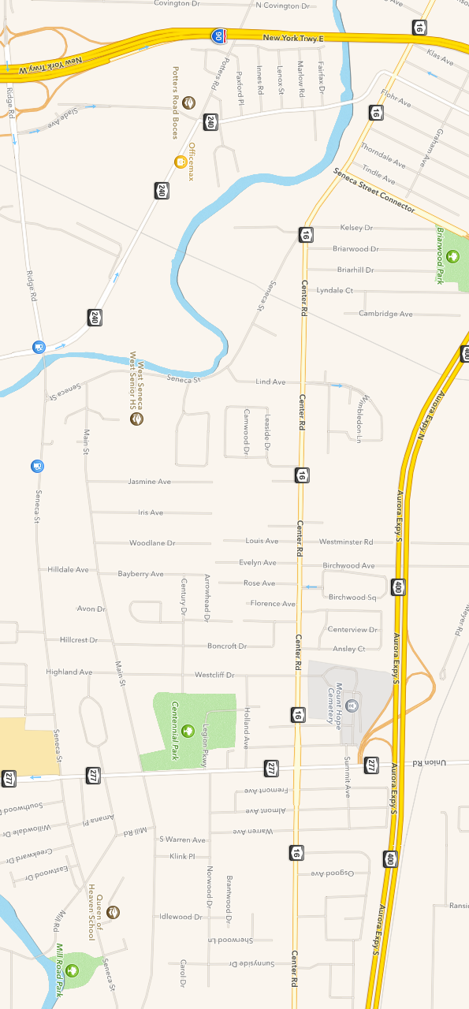

All games will be played at the:

West Seneca Town Rink

1250 Union Road

West Seneca, NY 14224

Directions:

From I-90 NYS Thruway Exit 54 Rt-400. Follow 1.5 miles to Rt-277 Union Road exit. Turn right on Union Road (Rt -277 South). Rink is 1/2 mile on right, behind the Town Hall. Enter rink via Legion Parkway and library access road.

West Seneca Youth Hockey Association

Presents the

Lukey’s Legacy Memorial Hockey Tournament

West Seneca Youth Hockey Association

C/O Tournament Director Jim Bowen  
P.O. Box 962

West Seneca, NY 14224

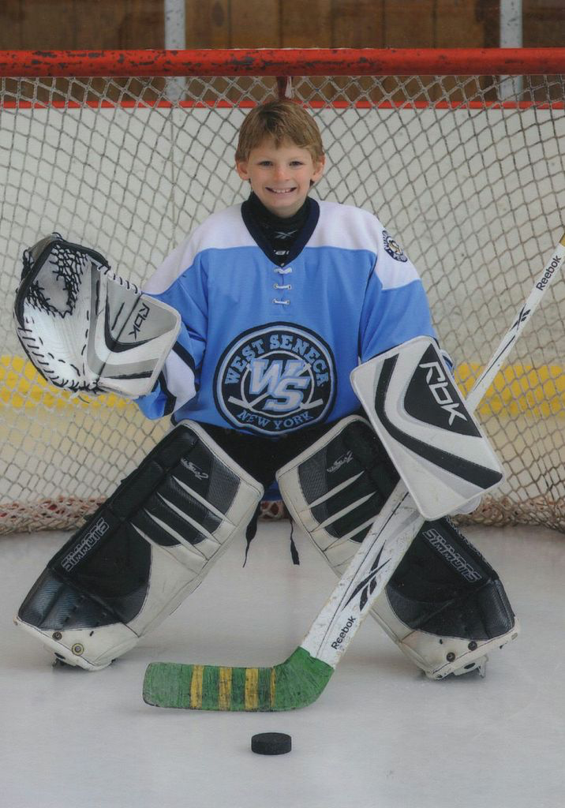

WSYHA Squirt House/MOHL Tournament

_________________________________ Team Name

_________________________________

Association

_________________________________

Coach

_________________________________

Phone

_________________________________

Email

_________________________________

Manager

_________________________________

Phone

_________________________________ Email

_________________________________  
Home Jersey Color

_________________________________

Away Jersey Color

The “Lukey’s Legacy”

Luke Gould Memorial

Squirt House Hockey Tournament is open to Squirt House (or MOHL) teams only, no Select or “Travel Tryout” teams

***Tournament Dates:***

**Monday March 27 thru Sunday April 2, 2017**

Local teams will be asked to play at least one weekday game

For more information, please contact:

Jim Bowen at 716-777-1396; jbowen@sahlen.com

Tournament fee includes:

• Three game minimum

• 10-10-12 minute periods with no curfew

• Change on the fly, no horn for shift changes

• Free admission for spectators

• Flexible scheduling

• Medals for 1st and 2nd place players

Tournament Fee: $500

Tournament proceeds will go to Lukey’s Legacy Foundation.   
To hold a spot, please submit a $100 check payable to:   
*West Seneca Youth Hockey Association*

*C/O Tournament Director*

*Jim Bowen  
P.O. Box 962*

*West Seneca, NY 14224*