Defense Penalty Corners – Principles

- Understand defensive scheme being used on each corner, and knowledge of individual roles
- Understand Start position & Finish position, and path to get there
- Decide whether runners/trails will pass in front of GK (possibly obscuring vision)
- Be aggressive in zone defense - protect goal and goal box
- Get out quickly to PRESSURE BALL, claim space and influence play
- FINISH PLAY out of circle! Ideally to sides.
- Players coming back from 50 yard line know where they go to assist on defense, but assign some to take positions to allow quick outlet away from center of field and counterattack. For example, see image below.

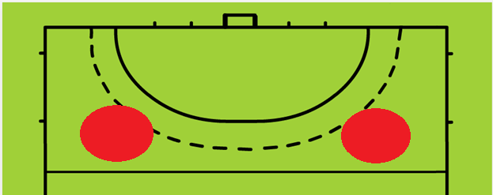

Defense Penalty Corners – Common Approaches
- 1-3
- 2-2 Left or 2-2 Right
- 2-2 low box

REMEMBER: Against a well-organized and skilled attacking team it is not possible to cover EVERY possible switch or option. So we focus on the primary threats, and have a plan for each.
Attacker terminology: “option left” or “option right” are from the attacker’s perspective. L1 and R1 are the players closest to and either side of the stop/strike at the top of the circle. L2 and R2 are on the outside.
In the following images:
- R is “Runner” or “Rusher” – Sometimes called a Flyer. Typically they are your speediest player and their objective is to get to the top of the circle as fast as possible and prevent the shooter or stopper having time on the ball. The may also pressure the option left. They have to choose between blocking the shot or letting it go?
- LT and RT are Left Trail and Right Trail respectively. Their roles vary. They typically cover a zone of the circle between the goal and the top of the circle for deflections and options. In some cases one or both may rush the top of the circle too behind the primary “Rusher” to cover the ball when switched to another attacker at the top. They will clear rebounds from the GK in their zone.
- P is “Post” – typically covers the left post and sweeps any balls away that get behind the goalkeeper. In games without a goalkeeper they will stand more centrally and cover the whole goal line. They may also control a deflection spot.
- GK stays home (two yards off line)

- 1-3
- Single Rusher pressures strike on top of circle and is also responsible for the Option Left in this scheme.
- Both trails pinch in and cover tippers or other options
  - Left Trail releases on an Option Right.
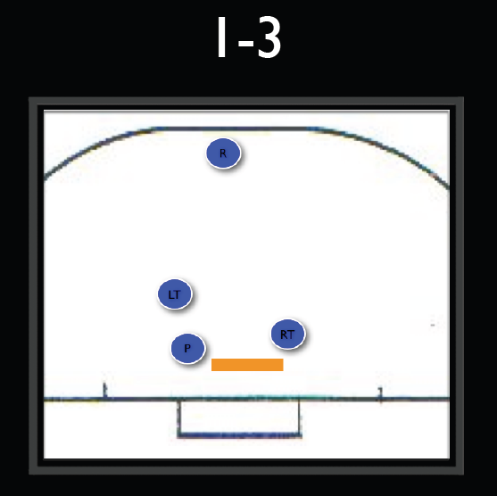
  - Right Trail is responsible for any tippers on right and the inserter, and will take a position advanced or deep based on opponent positions
- Post takes one step off the line and helps GK cover goal.
  - Post also covers any runners on the right post.

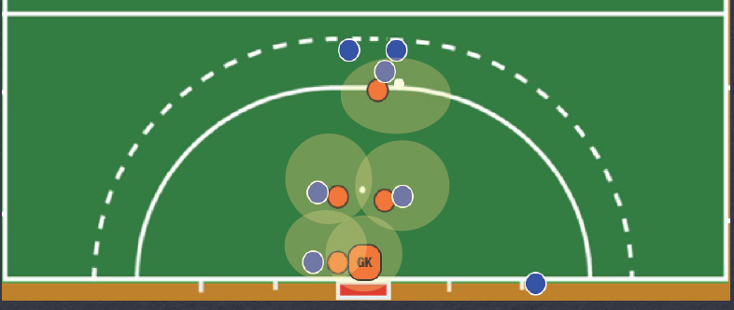

- 2-2 Right or 2-2 Left
- On a 2-2 Right both the Rusher and Right Trail release to pressure the primary shot or options at the top of the circle.
  - This scheme would be used to deter options to the right, but is less common than 2-2 Left
  - The Left trail and post maintain their 1-3 positioning.
  - Risks giving Injector or L2 Attacker too much room
  - A variant is where the Right Trail doesn’t commit fully to the option left, but takes a position about ten yards out where they can pressure the option left (L1) and also cover options to L2 or Injector.

- On a 2-2 Left the Left Trail joins the Rusher at the top of the circle in an effort to deter or intercept an option to the right.
  - The Right Trail and post maintain their 1-3 positioning or adjust to runners.
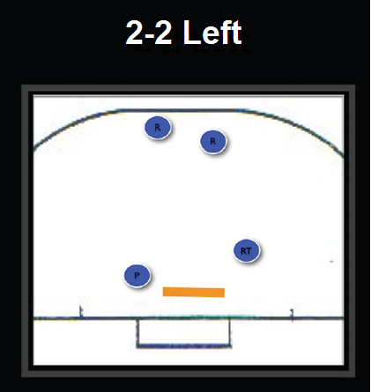
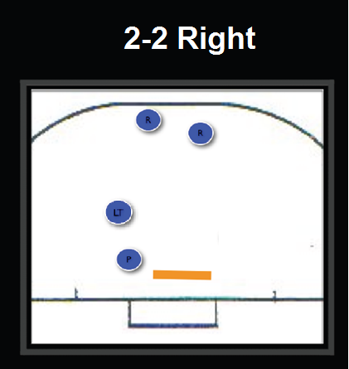
2-2 Low Box
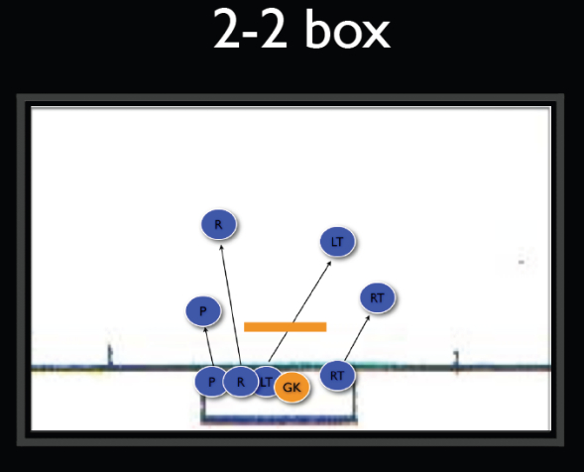
- 2-2 Low Box is where all four defenders stay near or below the stroke mark in an effort to defend all low slip/tipping options.
- The direct shot is conceded and becomes the responsibility of the keeper to defend on their own.
- This option would be the best choice for someone wishing to eliminate any tip-in goals and when the attacking team lacks a threat from the top of the circle.
- For defensive players who are low in the circle:
  - Read opponent’s body language
  - Box out
    - thigh against opponent’s stick!
    - shoulder in the middle of their chest!
  - Stay in the play
  - Defend the stick, not the body

