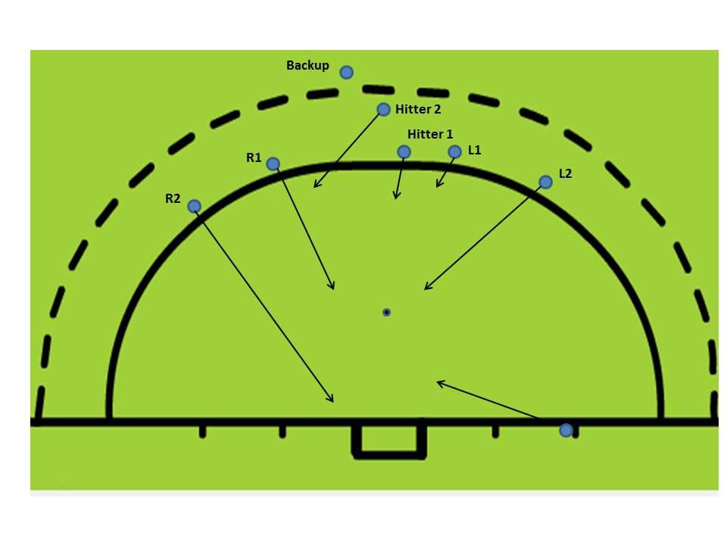
Positions
- Inserter 3 yards out and 1.5 yards outside post
- L2 8 yards out and 1.5 yards outside post
- L1 1.5 yards in circle and 1.5 yards outside post
- R2 1.5 yards outside post & 1.5 from end line for tip
- R1 8 yards out and aligned with post
- Hitter 2 moves behind Hitter 1, and 3 yards to right, 1 yard in.
- After strike, Hitter 1 adopts rebound position three to four yards inside circle
- For tippers (Injector, L2, R1 & R2), feet are just outside goal so that stick will be inside AND on the ground already. All we’re looking to do is redirect the ball with a touch from the stationary stick, not swing at it.
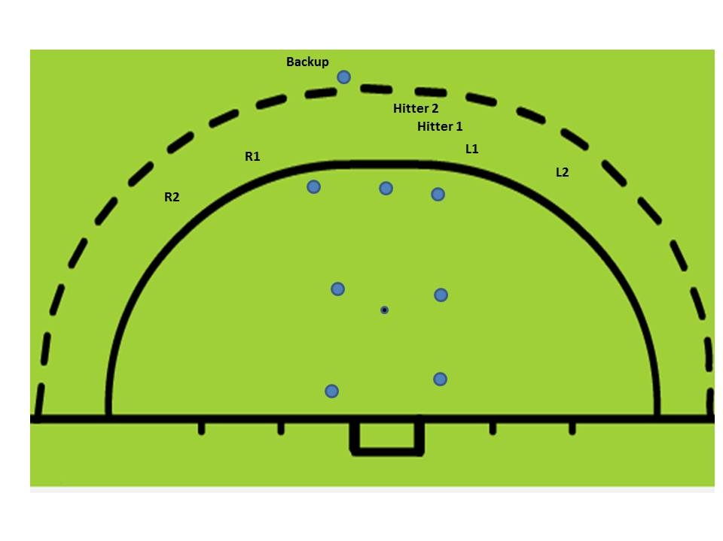
- Backup player on line of insertion to Hitter 1 but outside broken line in case trap is missed.
Options
- Straight shot by Hitter 1
  - toward left post – injector may get touch
  - toward right post for R1 or R2 touch
- Pass from Hitter 1 to L1, after committing lead runner, and L1 shoots to far post for R2 tip
- Pass from Hitter 1 to Hitter 2 (after committing runner):
  - for shot to far post. Injector might get tip.
  - for transfer to L1 for control and push. On turf L1 can deflect off edge on reverse
  - for transfer to Inserter to control and push
- Hitter 1 “misses” the stop. Release to broken line, everyone sheds right/center outside of flick spot; Backup controls ball and rolls back to L1 for open or reverse shot (no height restriction)

