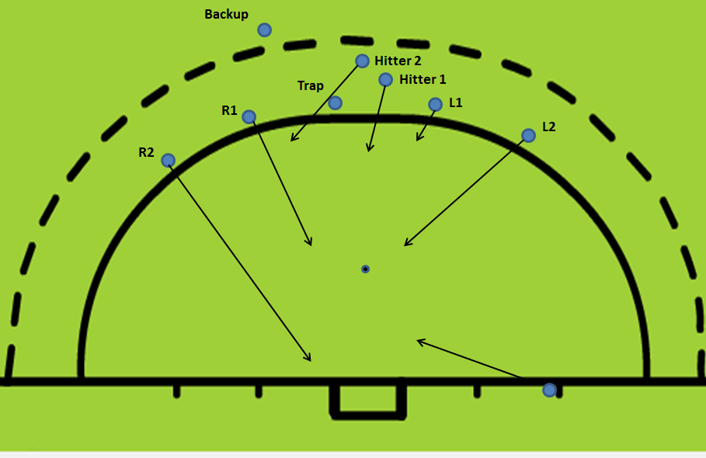
Positions
- R2 1.5 yards outside post and end line for tip
- R1 8 yards out and aligned with post
- L2 8 yards out a 1.5 yards outside post
- Injector 3 yards out and 1.5 yards outside post
- L1 1.5 yards in circle and 1.5 yards outside post
- Hitter 2 moves behind trap, and 3 yards to right, 1 yard in.
- After strike, Hitter 1 adopts rebound position three to four yards inside circle
- For tippers, feet are just outside goal so that stick will be inside and all we’re looking to is touch the ball, not redirect it.
- Backup on line of injection to trapper but outside broken line in case trap is missed (and for option 7).

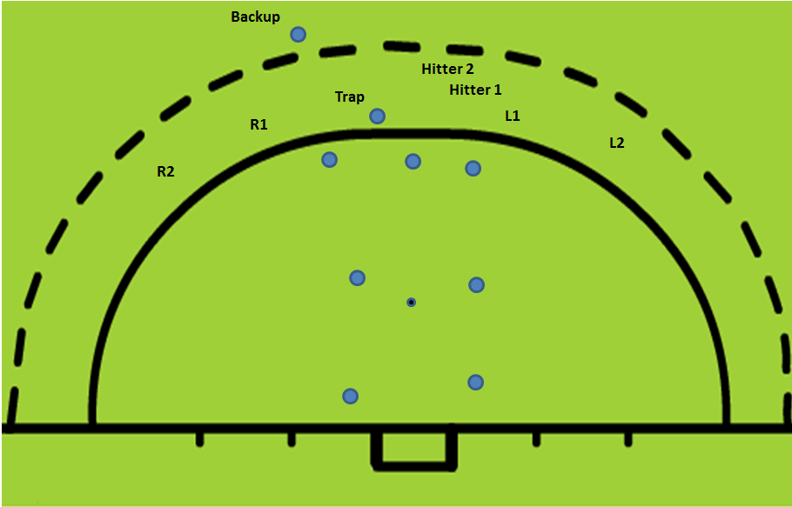
Options (for 1-6 ball is injected to trapper)
- Straight hit/drag flick.
- Pass to L1 and hit for R1 deflection or R2 tip
- Pass to Hitter 2 for shot to far post
- Pass to Hitter 2 for L1 deflection
- Pass to Hitter 2 for Injector deflection
- Straight hit for R1 touch
- Trap is “missed” and ball is controlled by Backup outside broken line, everyone sheds right/center outside of flick spot; roll back to L1 for reverse shot (no height restriction)

